


Title

Date Submitted:

Prepared by:
Alliance to End Homelessness in the Capital Region
The territory that we now refer to as the Captial Region District has a long and storied history as the traditional territory of the lək ̓ʷəŋən (Lekwungen) and W̱SÁNEĆ peoples and the Schian'exw (Beecher Bay), T'Sou-ke (Sooke), Elwha Klallam, and Makah First Nations.
We acknowledge and thank these peoples and communities for their continued stewardship, care, and leadership of these lands. The continued occupation of unceded Indigenous territory stands as a constant reminder of this country's colonial legacy and the harm that we have incurred upon the lands and her people.
It is important to recognize that the Indigenous community occupies a significant percentage of the unhoused populations. 5% of the Greater Victoria population identifies as Indigenous, and yet, in the 2023 Greater Victoria Point-In-Time Homeless Count, 33% of the unhoused surveyed identified as Indigenous. This disparity points to the long-term impacts of colonial systems and policies. It raises critical questions about how current support structures are addressing — or failing to address — the intergenerational effects of that history.

We gratefully acknowledge the financial support of the [name of organization] [name of grant goes here].

Table of Contents
Purpose and Scope 1
Homelessness in the Capital Regional District 1
Discussion of Homelessness 2
Municipalities that Permit Sheltering 4
Central Saanich 4
Parks 4
Roadways 6
Colwood 6
Parks 6
Roadways 8
Official Community Plans and Homelessness 8
Langford 8
Parks 9
Roadways 10
Official Community Plans and Homelessness 10
North Saanich 10
Parks 10
Roadways 12
Saanich 12
Parks 12
Roadways 14
Official Community Plans and Homelessness 14
Sidney 14
Parks 14
Roadways 16
Victoria 16
Parks 16
Roadways 20
Official Community Plans and Homelessness 20
Municipalities That Do Not Permit Sheltering 21
Esquimalt 21
Parks 21
Roadways 22
Highlands 23
Parks 23
Roadways 24
Metchosin 25
Parks 25
Roadways 25
Official Community Plans and Homelessness 26
Oak Bay 26
Parks 26
Roadways 27
Official Community Plans and Homelessness 28
Sooke 28
Parks 28
Roadways 29
Official Community Plans and Homelessness 30
View Royal 30
Parks 30
Roadways 31
REGIONAL LEGISLATION 32
Parks 32
Roadways 32
PROVINSIONAL LEGISLATION 34
Parks 34
Roadways 35
FEDERAL LEGISLATION 36
Department of National Defence Lands 36
Appendix A: Glossary 38
Appendix B: CRD Bylaw for Parks and Roads 40
Appendix C: Saannich – Bylaw 7753 - Schedule “C” 49
Appendix D: Esquimalt – Bylaw No. 2664 – Schedule “A” 52
Appendix E: British Columbia – Motor Vehicle Act – Regulations on Parking 53

Introduction

Purpose and Scope
Across the Capital Region District (CRD), parks and roadways play a central role in community life. They serve as public spaces that foster connection, recreation, and access to many stunning natural spaces. The preservation and maintenance of these areas is a shared responsibility undertaken by municipalities across the region. From rocky coastal trails to temperate rainforests and mountain trails, the CRD boasts some of the most beautiful natural landscapes in the world.
As housing costs continue to rise in recent years, public parks and roadways have become prominent parts of the discussion surrounding homelessness on the island. This shift has brought renewed attention to the legal policies and frameworks governing public space access.
In 2008, the right to shelter in public parks became a question faced by the BC Supreme Court. Victoria (City) v. Adams addressed the
inevitable conflict between the need of homeless individuals to perform essential, life-sustaining acts in public and the responsibility of government to maintain orderly, aesthetically pleasing public parks and streets (2008).
The defendants argued that the city's prohibitions against temporary shelters infringed upon the unhoused’s right to life, liberty and security of persons, rights guaranteed in section 7 of the Canadian Charter of Rights and Freedoms. Ultimately, the Supreme Court ruled in Adam's favour, declaring that Victoria’s prohibition violated the Charter (Victoria (City) v. Adams, 2008).
This ruling illustrates the ongoing complexity faced by municipalities in balancing the protection and stewardship of public spaces with the needs of individuals experiencing homelessness. Balancing the unhoused's needs and the public's best interest is the challenge. However, with an increased municipal focus on affordable housing and the needs of the unhoused, the CRD is making strides towards tackling the ever-evolving issue of homelessness.
This report will examine the evolving discussion surrounding sheltering in parks and roadways through an in-depth analysis of municipal bylaws, provincial regulations, and federal laws governing the 13 districts of Southern Vancouver Island, collectively known as the Capital Region District. The scope of this report will begin with a brief overview of homelessness in the CRD, drawing upon provincial and regional data sets to frame the discussion of homelessness in the district. The body of this report will begin by subdividing the districts into two separate categories: the districts that permit temporary overnight shelters and those that do not. Within each category, this report will analyze the bylaws of each district to evaluate how they individually impact the unhoused community. Additionally, each district's Official Community Plan (OCP) will be analyzed for their discussion of the unhoused community. Where homelessness is an issue that touches every corner of this country, not every OCP discussed homelessness. Consequently, this report will focus exclusively on the OCPs directly addressing that issue. Finally, this report will analyze the regional, provincial, and federal laws governing roads and green spaces.

Homelessness in the Capital Regional District

Homelessness in the Capital Regional District (CRD) is a multifaceted and evolving issue that intersects with housing availability, affordability, mental health, substance use, and broader social and economic factors. While the region has taken steps toward addressing these challenges through investments in supportive housing and community-based services, a significant number of individuals continue to experience housing instability or live without adequate shelter. In 2023, a Point-in-Time (PiT) Count conducted across the CRD revealed 1,665 individuals experiencing homelessness in Greater Victoria. PiT Counts serve as a valuable database for decision makers, providing helpful information to government agencies, community organizations, and non-profit service providers, guiding these agencies towards programs and policies that reflect the needs of the unhoused and those at risk of homelessness. However, PiT Counts fail to reflect an accurate count of the unhoused population. Those experiencing homelessness are not universally visible to the public, which renders the PiT count as the absolute minimum number of individuals experiencing homelessness when the count took place. Consequently, the PiT Count stands as an underestimate; it does not reflect the number of individuals experiencing hidden homelessness, including hospital and rehab patients and couch surfers.
Despite the limitations imposed by this data, the PiT studies provide a "snapshot" of homelessness in the region. Of the 1665 individuals surveyed, 32.9% identified as Indigenous. The Indigenous community represents nearly a third of the unhoused population surveyed but only accounts for 5% of Victoria's population (Davis et al., 2023).
All of the districts across the CRD exist upon the unceded territories of the lək ̓ʷəŋən (Lekwungen) and W̱SÁNEĆ peoples, represented today by the Schian’exw (Beecher Bay), T’Sou-ke (Sooke), Elwha Klallam, and Makah First Nations. These communities are not immune to the history of colonization, and for the unhoused Indigenous individuals seeking shelter in city parks, these bylaws hold far less precedent than their ancestral claim to these lands. In 2018, this became a legal issue when the district of Saanich attempted to remove an encampment from Regina Park. One of the defendants, Christine Brett, refused to vacate, stating that she "had seized Regina Park land pursuant to a proclamation from the year 1700" (Saanich (District) v. Brett, 2018). Legal cases like Saanich v. Brett, alongside the disproportionate representation of Indigenous peoples amongst the unhoused community highlight the ongoing challenges and structural inequities that continue to affect Indigenous communities across the country.
Finally, this report would like to note the challenge that people of colour, women, and members of the LGBTQI+ community face many additional challenges as unhoused members of our community. Family members and/or landlords imbued with prejudice and/or bias can increase the likelihood of housing insecurity in these communities. In the broader discussion of homelessness, we must ensure that the needs of these diverse communities are met with equal compassion and care.

Discussion of Homelessness
Understanding homelessness begins with our collective understanding of what it means to be unhoused. Homelessness, as it is understood by the Canadian Observatory on Homelessness (COH) "describes the situation of an individual, family, or community without stable, permanent, appropriate housing, or the immediate prospect, means, and ability of acquiring it" (Gaetz et al., 2012). Within that framing, the COH goes a step further, organizing corresponding terms into a typology that will assist in our understanding of the issues at hand. This typology includes:
- Unsheltered or absolutely homeless and living on the streets or in places not intended for human habitation;
- Emergency Sheltered, including those staying in overnight shelters for people who are homeless, as well as shelters fort hose impacted by family violence;
- Provisionally Accommodated, referring to those whose accommodation is temporary or lacks security of tenure
- At Risk of Homelessness, referring to people who are not homeless, but whose current economic and/or housing situation is precarious or does not meet public health and safety standards. (Gaetz et al., 2012)
Framing our discussion around a comprehensive and multifaceted understanding of homelessness allows for a nuanced approach to addressing its root causes and finding sustainable solutions that consider the diverse needs of those affected.
Additionally, we have chosen to use the term "unhoused" instead of "homeless." As an adjective, homelessness emphasizes what an individual lacks, whereas unhoused emphasizes what has happened to the individual in question. The term "unhoused" reinforces the idea that housing is not a privilege but a fundamental human right. Shifting the tone and the discourse around homelessness will impact how we advocate for positive change in public discourse and political policy.
Understanding homelessness through a systemic lens allows us to move beyond stereotypes and misconceptions that place undue blame on individuals. Instead, it highlights the broader economic, social, and political forces—such as rising housing costs, stagnant wages, and insufficient social support systems—that contribute to the growing number of unhoused individuals.

Sheltering in the capital regional district
This section has been broken down into two sections: the districts that permit sheltering overnight and those that do not. Following the discussion of sheltering in parks, this comprehensive report will analyze the bylaws that address sheltering on roadways. Following the municipal breakdown, we will proceed to discuss the provincial and, finally, the federal regulations that overlap with the CRD, providing a thorough understanding of the legal landscape.

Municipalities that Permit Sheltering
Seven municipalities within the Capital Regional District permit temporary overnight shelters in parks: Central Saanich, Colwood, Langford, North Saanich, Saanich, Sidney, Victoria, and the electoral districts of Salt Spring Island, Juan de Fuca and the Southern Gulf Isles. Each jurisdiction has bylaws governing the use of municipal parks and roadways. This section examines those bylaws on a case-by-case basis. For each district, a brief introduction and a map of municipal parks will be provided, followed by an overview of relevant bylaws related to sheltering in parks and, subsequently, sheltering on roadways.

Central Saanich
Located in the heart of the Saanich Peninsula, Central Saanich is on the traditional territory of the W̱SÁNEĆ people, which includes W̱JOȽEȽP (Tsartlip) and SȾÁUTW̱ (Tsawout) First Nations. Home to over 17,000 residents (Central Saanich, 2025), the municipality governs 25 parks, (see Figure 3).

Parks
Figure 3
Central Saanich Parks and Trails Map
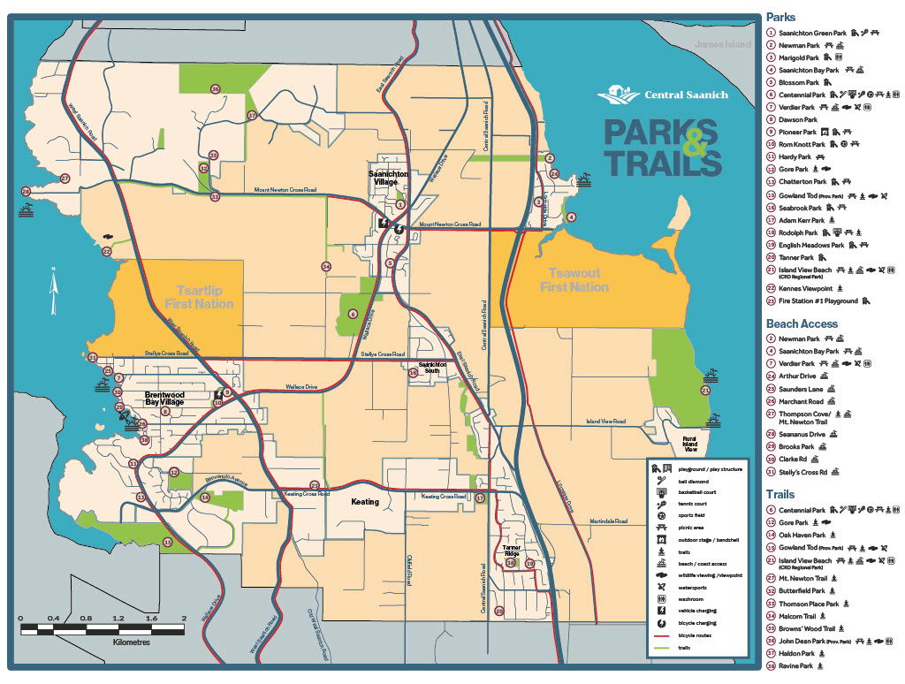
Note: Central Saanich, date unknown
These parks are covered by the Parks, Beaches, and other Public Places bylaw, adopted by Central Saanich in 1985. The bylaw contains 31 sections, and section 13 directly addresses the question of temporary overnight shelters (Central Saanich, 1985).
Section 13 begins:
No person may erect or construct, or cause to be erected or constructed, a tent, building or structure, including a temporary structure such as a tent, in a park without first obtaining written permission from the District.
Subsection (a) directly underneath this section stipulates that an unhoused individual may shelter “where there is no accessible shelter accommodation available in the District.” As we will demonstrate, this conditional language appears consistently across municipalities in the CRD that permit sheltering. However, there are limited emergency shelters for the unhoused outside of Victoria in the CRD. Consequently, this language is somewhat misleading, although it may suggest that Central Saanich is looking to develop accessible accommodation within the district.
Additionally, subsection (a) outlines a list of “Prohibited Areas” within the district, and individuals must consult this list to determine where sheltering is not permitted. “Prohibited Areas,” according to the district, include:
maintained or landscaped public lawns, beaches, playgrounds, gardens, tennis courts or other sports facility courts, sports fields, dugouts, stages, bleachers, washroom facilities, picnic shelters, gazebos, pathways, driveways, roadways, lanes, bridges, docks, wharfs, boulevards, areas of a Park that have otherwise been issued a permit pursuant to this bylaw, and all other offices, community and recreational facilities, and parking lots that are owned by the District (Central Saanich, 1985).
This regulation includes several public use spaces designated for a specific function, such as tennis courts, playgrounds, or pathways. Restricting the unhoused from sheltering on or in these spaces seemingly prioritizes preserving designated recreational and public-use areas, reflecting a municipal interest in maintaining access, safety, and intended use. However, the extensive scope of these restrictions may limit the number of viable locations available for individuals seeking temporary shelter, particularly in municipalities without dedicated emergency shelter facilities. Including “maintained or landscaped public lawns” as a prohibited area restricts the unhoused to rugged and hidden sections within public parks.
Subsection (b) introduces a time-based limitation for the unhoused, with a designated window between 7:00 p.m. and 9:00 a.m. While designed to address potential safety, maintenance, and public use concerns, they can contribute to recurring displacement for individuals without access to permanent shelter.
This restriction adds further complication when personal possessions are considered. Sheltering in a park outside of the designated hours places the personal possessions of an unhoused individual at risk of seizure or disposal. Police and Bylaw officers possessing seized property may classify unhoused belongings as “refuse,” landing these belongings in the trash. All remaining “chattel” seized by the District can be challenging to retrieve. The loss of personal property often places an emotional and/or economic burden on the individual in question, jeopardizing their health and well-being
Subsection (c) of the bylaw introduces a further limitation, prohibiting temporary overnight shelters from adjoining or connecting to one another. While intended to prevent the establishment of encampments, this clause may also limit the sense of safety or mutual support that can arise from proximity to others. Individuals may be reluctant to leave their temporary shelter due to concerns about the security of their belongings in their absence.

Roadways
Central Saanich has legislated two separate bylaws regarding sheltering on roadways: Bylaw No. 2018, established to regulate traffic and the use of highways, and Bylaw No. 804, addressing Parks, Beaches, and other Public Places.
Bylaw No. 2018 prohibits individuals from stopping on a highway, road, street or lane “for the purpose of temporarily residing or sleeping between 9:00 pm and 6:00 am” (Central Saanich, 2019). This bylaw restricts individuals from sleeping on a roadway, excluding private property and parking lots. Frequently regulated by time restrictions or parking fees, parking lots often have restrictions that significantly impact one's ability to shelter. The bylaw concerning Parks and Beaches also prohibits motor vehicles from remaining in a public park between 11:00 pm and 6:00 am.
Although primarily intended to ensure public safety, these restrictions limit access to key spaces that individuals might rely on for temporary refuge, especially when emergency shelters are unavailable. These regulations can contribute to the cycle of displacement faced by individuals without stable housing. When forcibly displaced, the unhoused must relocate or face penalties for non-compliance. Failure to comply with these bylaws only places an additional economic burden upon individuals who frequently lack a significant and consistent means of income.

Colwood
Located on the ancestral lands of the Teechamista and the lək ̓ʷəŋən-speaking people of the Songhees and Xwsepsum Nations, the City of Colwood is home to approximately 19,000 residents as of April 2023 (Colwood, 2023). With over 7 km of “pristine ocean waterfront,” and 52 parks (illustrated in Figure 4), this fast-growing seaside community is home to several historic sites, including Hately Castle at Royal Roads University and Fort Rodd Hill (Colwood, 2023).

Parks
Figure 2
Colwood Parks and Open Spaces Map
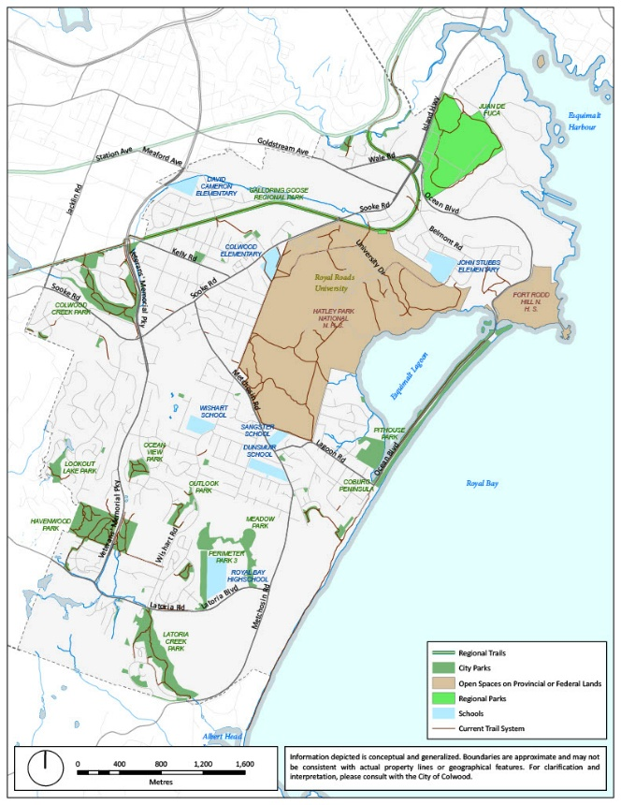
Note: Colwood, date unknown
In 2019, Colwood adopted Bylaw No. 1771, intended for the “management, control and use of parks, beaches and public open spaces,” within the city. Section five contains six subsections, alongside various clauses, that address the use of temporary overnight shelters within Colwood’s municipal parks. Subsection 5. (2) states:
Where there is no accessible overnight shelter accommodation available with the City of Colwood or the vicinity thereof a person who has neither a fixed address nor a predictable safe residence to return to on a daily basis may, subject to the restrictions set out in subsection (3), erect and occupy a temporary overnight shelter in a park (Colwood, 2019).
The language discussing “accessible overnight shelter accommodation” within the District echoes the framework of Central Saanich’s temporary overnight shelter bylaw. However, Colwood takes their bylaw one step further by extending the bubble for emergency shelters to include “the vicinity thereof.” As a fundamental framework, the City of Colwood likely adopted these regulations to address immediate sheltering needs while balancing public space management. However, the lack of clarity around the term “vicinity thereof” introduces ambiguity, potentially complicating the application and enforcement of the bylaw for individuals seeking temporary shelter.
Subsection 5. (3) provides the time-based limitations for temporary overnight shelters. It states that a shelter “not be erected before 7:00 pm on any one day,” and must be removed by 8:30 am the following day (Colwood, 2019). These restrictions ensure that public parks can be accessed by all members of the public during the most active times of day. However, for individuals experiencing homelessness, these time-based limitations enforce a cycle of constant displacement, contributing to a pattern of instability.
The fourth subsection provides a series of location-based limitations on shelters within Colwood’s parks. It begins by prohibiting shelters from within 40 meters of various public amenities, such as playgrounds, beaches and skate parks. These restrictions aim to preserve public access to the district’s amenities, while permitting the unhoused to shelter, Additionally, the restrictions that prohibit temporary overnight shelters on public roads, bridges, and parking lots illustrate a care and attention for the wellbeing of the unhoused. However, reliance on precise knowledge of distances, like the 40-metre restrictions, imposes conditions upon temporary shelters that may not be publicly available to the unhoused. The final subsection 5. (4) prohibits the unhoused from sheltering within “an environmentally sensitive area” (Colwood, 2019). While this limitation is clearly intended to help preserve our natural environment, clearly identified “environmentally sensitive areas” are needed to ensure compliance with this regulation.
Any temporary shelter that fails to abide by the bylaw “constitutes a chattel unlawfully deposited in a Park” (Colwood, 2019), permitting any law enforcement or bylaw officer the right to remove and impound the items in question. Once seized, these possessions may be held, sold, or disposed of “in accordance with the provisions of section 6” (Colwood, 2019). For individuals experiencing homelessness, the bureaucratic process of retrieval may prove exceedingly difficult. Additionally, when items are deemed as refuse, they may be discarded. This can result in the loss of essential possessions and may contribute to further hardship for the unhoused.

Roadways
The Parks Management Bylaw includes two separate provisions related to sleeping in public spaces. To begin, subsection 4. (8) (a) prohibits individuals from sleeping overnight in a vehicle within park boundaries. Additionally, subsection 5. (5) (a) states that temporary overnight shelters must not obstruct any highway, road, or lane. Although this subsection does not apply to an individual sleeping within a vehicle, this legislation prioritizes the safety of the unhoused while additionally ensuring that park roads are fit for public use. However, the restrictions imposed upon sheltering within a vehicle can leave individuals with limited options.

Official Community Plans and Homelessness
Colwood includes “Homelessness” as a “Key Area of Local Need” within the broader discussion of housing in the district, alongside “Affordable Housing,” and “Rental Housing” (Colwood, 2018). Although the description is brief, the document notes that homelessness is rising with the CRD. Objective 9.2.2, policy 9.2.2.1 additionally addresses the district's need for non-market and rental housing. The focus on new affordable rental housing illustrates the district’s awareness of the current rental housing challenges across the CRD. Additionally, subsection e. calls for Colwood to seek:
partnerships with non-profit agencies and other levels of government to access housing programs directed towards specific populations, such as…those at risk of homelessness (Colwood, 2018).
While brief, Colwood’s recognition of homelessness as a key area of concern—paired with its commitment to collaboration and support for non-market housing—reflects an understanding of the broader housing pressures within the region and a willingness to explore solutions in partnership with other stakeholders.

Langford
Located on the traditional territory of the Coast Salish peoples, specifically the Xwsepsum (Esquimalt), lək ̓ʷəŋən (Songhees), Sc’ianew (Beecher Bay), and the W̱SÁNEĆ Peoples represented by the Tsartlip, Pauquachin, Tsawout, Tseycum, and Malahat Nations, Langford the City of Langford is one of largest districts by population size within the CRD. As of 2022, the city had approximately 49,345 residents, experiencing consistent growth across the last decade. Langford is home to over 2,200 acres of green space and has several provincial, regional and municipal parks (Langford 2025).

Parks
Figure 3
City of Langford Parks and Trail Map
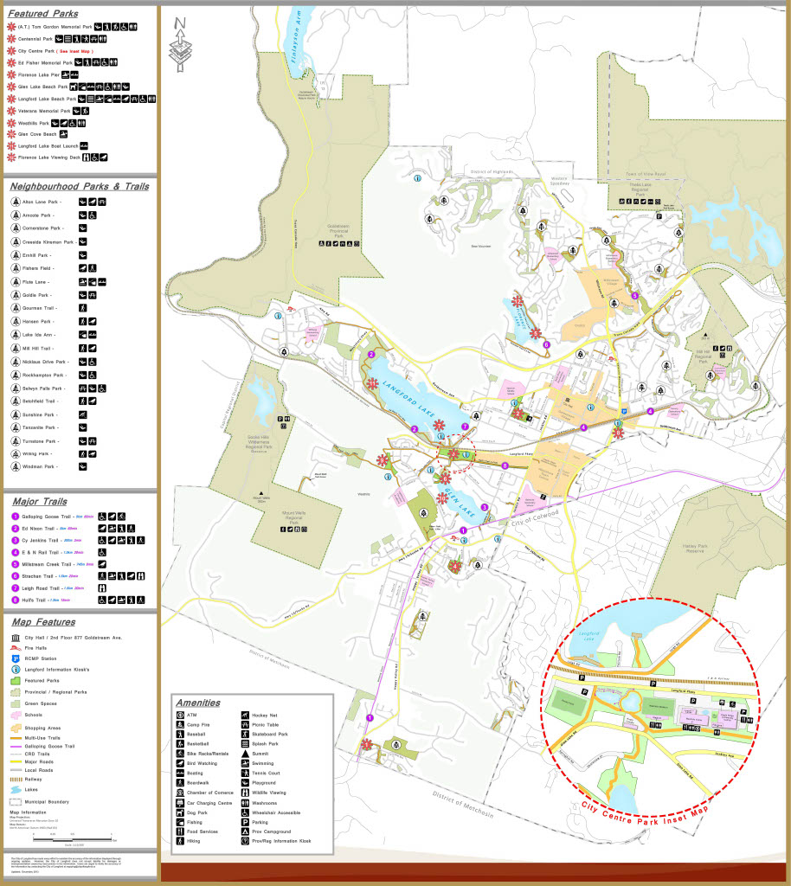
Note: Langford, 2013
The City of Langford is home to a wide array of green spaces governed by various levels of government. While the City regulates all municipal parks, regional parks, like Thetis Lake, are governed by the CRD, and provincial parks, such as Goldstream Provincial Park, are governed by the Province. This section will focus exclusively on the municipal parks and the bylaws that regulate their use, while sections two and three will focus on regional and provincial legislation, respectively.
Langford’s bylaws regulating temporary overnight sheltering in parks include time-based restrictions, requiring shelters to be removed by 7:00 a.m. These requirements can be particularly difficult for individuals lacking electricity access or facing mobility challenges. While intended to maintain accessibility and order in public spaces, these limitations may contribute to a cycle of frequent relocation for those sheltering outdoors.
The clauses listed under (c) and (d) pose additional location-based restrictions on temporary shelters. Cause (c) prohibits temporary overnight shelters within 10 meters of public bathrooms, beaches, roads, and trails. At the same time, clause (d) imposes a 100-meter prohibition on shelters near playgrounds, gardens, sports facilities, picnic shelters, gazebo, or cenotaph.
These restrictions establish guidelines for the use of temporary overnight shelters. By prohibiting sheltering near essential amenities such as washrooms and beaches, as well as recreational or ceremonial areas like sports facilities and cenotaphs, this clause prioritizes general use for public amenities. While intended to preserve the intended use of public spaces, these regulations may overlook the challenges unhoused individuals face in accessing safe, dignified, and functional shelter.
The subsequent bylaw following the discussion of temporary overnight shelters declares that “any temporary overnight shelter erected or maintained contrary to this bylaw my be removed under subsection 6.4” (City of Langford, 2023). Subsection 6.4 permits the city to “remove, seize and impound or cause the removal, seizure or impoundment of any chattel,” (Langford 2023) within the park; this subsection places the possessions of the unhoused at risk for disposal, placing an economic burden on the unhoused to replace their lost belongings.

Roadways
Langford has no bylaws restricting individuals from sleeping in their cars while parked in a city park. However, the same can not be said of the city’s roadways. Traffic Bylaw 33, adopted by the City in 1997, prohibits individuals from using “any vehicle, trailer or camper parked on a road” for lodging, sleeping or as a residence. This regulation leaves the unhoused with fewer options for safe and legal shelter, potentially forcing them into more precarious situations.

Official Community Plans and Homelessness
The Official Community Plan for Langford focuses chapter seven on a discussion of “Our Housing,” In the introduction, the city notes that access to affordable housing has become a pressing concern in the region. Consequently, Langford’s OCP designates a considerable discussion to increase affordable housing in the region while aiming to access housing programs directly for at-risk populations, including those at risk of homelessness (Langford, 2024). Policy 7.6.1 states that the city “will work with local social service providers, culture or religious groups, and senior levels of government to locate emergency shelter facilities in the community on an as needed basis” (Langford, 2024). Langford’s OCP illustrates that the district is actively working to address the needs of the unhoused community.

North Saanich
Located at the northern tip of the Saanich Peninsula, the district of North Saanich is part of the ancestral lands of the WSÁNEĆ peoples, today represented by the WSIḴEM (Tseycum), and the BOḰEĆEN (Pauquachin) First Nations (North Saanich, 2025). Home to approximately 12,000 residents, this rural-residential district encompasses the Victoria International Airport, the Swartz Bay Ferry Terminal and the 443 Maritime Helicopter Squadron for the Canadian Armed forces (North Saanich, 2025).

Parks
Figure 4
North Saanich Parks and Community Amenities
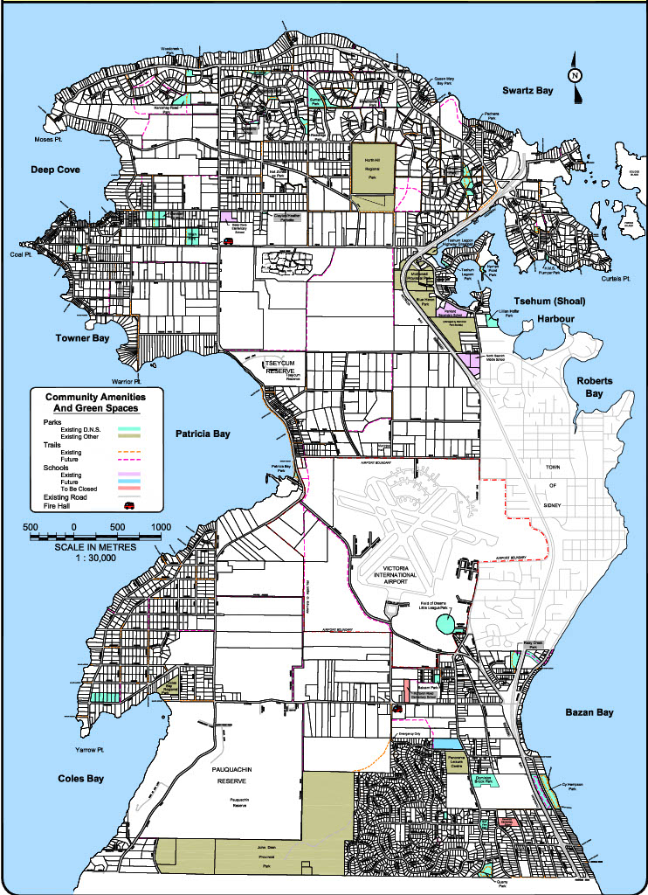
Note: North Saanich, 2007
North Saanich encompasses 29 local parks collectively governed by the municipality. Falling directly under the heading “Temporary Overnight Shelters,” section 22 states that an unhoused person may erect a temporary overnight shelter “[w]here there is no overnight shelter accommodation available within the District of the vicinity thereof” (North Saanich, 2018). This section serves to establish conditions for the use of temporary over night shelters. However, without clarifying what “vicinity thereof” constitutes, it is difficult to determine what initial conditions must be met to shelter overnight in North Saanich. The closest emergency shelter to the district is over 25 kilometres away, imposing a significant burden on the unhoused to relocate if the “vicinity thereof” encompasses the shelters in Victoria.
The remainder of the bylaw provides time and location-based restrictions. Shelters in North Saanich “must not be erected before 7:00 p.m. in any one day and must be taken down and removed before 9:00 a.m. on the following day,” (North Saanich, 2018), providing a larger window for occupation than Central Saanich, Langford or Colwood.
The location-based restrictions outlined in the North Saanich Bylaw limit where temporary overnight shelters can be set up in local parks, but it is more lenient than some other districts. While the bylaw restricts shelters from being placed “within or upon” park features, such as playgrounds, beaches, and sports courts, it does not provide any meter-based distance limitations (North Saanich, 2018). Consequently, while individuals cannot set up shelters for public amenities, the bylaw is less stringent than other districts that impose a defined distance. These rules allow for more flexibility but still aim to protect high-traffic or sensitive areas from disruption.
Moreover, the bylaw does not threaten to dispose of any shelters that do not comply with these bylaws. The penalties outlined are economical, falling between $1,000 and $10,000 for each offence (North Saanich, 2018). Where the economic penalties would surely impose an untenable burden on the unhoused, the district does not directly threaten the personal property of the unhoused.

Roadways
Two separate bylaws in North Saanich address sheltering on roadways: Bylaw No. 1261, regulating streets and traffic, and Bylaw No. 1470, regulating the use of parks. Under the heading “Stopping, Standing and Parking Vehicles,” Bylaw 1261 explicitly prohibits a vehicle “on any highway, or within the same block on either side of the roadway for a continuous period exceeding 24 hours,” (North Saanich, 2015). While this bylaw mandates that parked vehicles relocate every 24 hours, it does not explicitly forbid an individual from sheltering within their car.
However, the same can not be said about vehicles within public parks. Bylaws 1261 and 1470 collectively prohibit individuals from parking their vehicles “in any public park or school ground between midnight and 6:00 am” (North Saanich, 2015). These restrictions create barriers for individuals seeking to use their vehicles as temporary shelters, leaving them with limited options for safe and legal overnight accommodation. As a result, unhoused individuals may be forced to park in unsafe or illegal areas, increasing their vulnerability.
Bylaw 1470 prohibits an individual from erecting a temporary overnight shelter on roadways, bridges, or dedicated highways (North Saanich, 2018). By restricting the presence of temporary overnight shelters on roadways, this bylaw prioritizes public access to these spaces while ensuring safety for both the unhoused and the public. This restriction promotes the safe use of roads and minimizes potential conflicts with traffic and other public functions.

Saanich
Saanich encompasses 103.44 square kilometres of territory and is home to over 114,000 people, making the district the largest and most populous within the CRD. The district occupies the ancestral lands of the lək ̓ʷəŋən peoples, today represented by the Songhees and Esquimalt Nations, as well as the W̱ SÁNEĆ peoples; the W̱ JOȽEȂP (Tsartlip), BOḰEĆEN (Pauquachin), SȾÁUTW̱ (Tsawout), W̱ SIḴEM (Tseycum), and MÁLEXEȂ (Malahat) Nations. (Saanich, 2025).

Parks
Figure 8
Saanich Parks
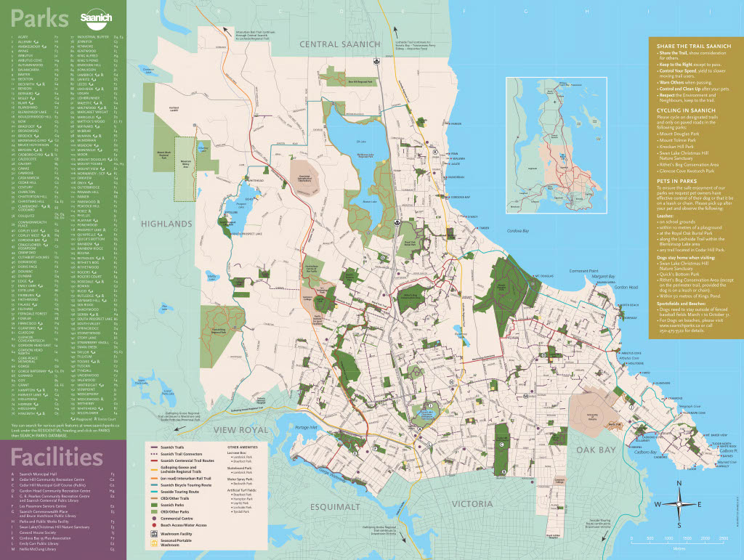
Note: Saanich, date unknown
As the largest municipality within the CRD, Saanich is home to many regional and municipal parks. These green spaces encompass the University of Victoria, Elk Lake, and Swan Lake, amongst over 170 additional parks. A range of jurisdictions govern the parks; however, the Parks and Management Control Bylaw, adopted by Saanich in 1997, regulates the majority of the green spaces within the district.
Point 14.1 of the Parks Management Control Bylaw provides the general regulations for an overnight shelter within Saanich’s parks. This provision specifies that a person can erect a temporary overnight shelter “where there is no accessible overnight shelter accommodation available within the District of Saanich or the vicinity thereof," (Saanich, 1997). Unfortunately, the bylaw fails to define “vicinity thereof,” imposing a significant degree of ambiguity on the specifications of this bylaw.
Subsection 14.1(b) states that any temporary shelter erected or occupied in a park that does not adhere to the regulations outlined in Schedule "C" will be considered an unlawful deposit. This stipulation in the bylaw means the shelter and any associated belongings could be classified as “chattel” and removed, seized, impounded, and potentially sold.
Diving the temporary overnight shelter regulations into two documents (the Parks Bylaw and Schedule “C”) creates additional barriers to a comprehensive understanding of Saanich’s bylaws. The regulations laid out in Schedule "C" provide a more detailed breakdown of temporary shelter guidelines. It includes three main components: time restrictions, location-based restrictions, and a list of parks where shelters are permitted.
Schedule “C” lists 81 parks where temporary overnight shelters are permitted. This list, separated from the body of the bylaw, adds an additional challenge to compliance with the bylaw. Any individual hoping to shelter within a Saanich park must first confirm that the park is on this list or risk the seizure of their possession. Additionally, temporary overnight shelters are not permitted on environmentally sensitive areas, beaches, gardens, and walkways. These regulations illustrate Saanich's attention to balancing the needs of the unhoused community with the public's best interests. However, it is important to emphasize that the unhoused must be able to access and understand these regulations to ensure they function as a productive tool for this dynamic district.

Roadways
Saanich has two separate bylaws that directly impact sheltering in a vehicle: the Parks Management and Control Bylaw (No. 7753) and the Streets and Traffic Regulations Bylaw (No. 8382). The Parks bylaw prohibits individuals from parking “in any park at any time between the hours of 11:00 p.m. and 6:00 a.m.,” (Saanich, 1997) the following day. This regulation effectively limits the use of the park’s parking lots for overnight shelter.
The Streets and Traffic Regulations outlines further restrictions for vehicles as shelters. Subsection 7.17 states
No person shall use any vehicle or trailer parked on a street for the purpose of lodging, sleeping accommodation or a residence (Saanich, 2002).
This bylaw keeps individuals from using public roadways as shelter. Consequently, there are few legal options for those seeking to shelter overnight in their vehicle. Furthermore, the few locations that permit overnight vehicle shelters often come with an economic barrier to entry. For those with little disposable income, these costly legal options may not be accessible.

Official Community Plans and Homelessness
Chapter eight of Saanich’s OCP, “Housing,” discusses how the housing crisis has impacted the district and its residents. The OCP notes that the district has a limited housing stock and extremely low vacancy rates, putting more individuals “at risk of unsuitable housing and homelessness” (Saanich, 2024). After discussing the challenges concerning housing in Saanich, the OCP proceeds to develop well-researched policy objectives to increase rental and affordable housing.
Section 8.3, “Affordable and Supportive Housing,” provides several clear objectives focused on addressing the issue of homelessness. Policy 8.3.10 identifies the need to develop a comprehensive range of housing options for those at risk of homelessness, including shelter, transitional housing, and supportive housing. This approach lessens the burden other emergency and critical housing providers feel across the district (Saanich, 2024). The OCP legislation continues to echo this tone with the attention directed toward developing non-market housing units. The increased attention toward discussing affordable housing and homelessness within the district provides Saanich with obtainable objectives to help reduce housing insecurity across the CRD.

Sidney
Located on the northeastern coast of the Saanich Peninsula, the Town of Sidney is located on the ancestral territory of the W̱SÁNEĆ peoples, including the Tsartlip, Pauquachin, Tseycum, Tsawout, and Malahat First Nations. With a population of approximately 12,318 people, this waterfront community is the closest urban center to the Swartz Bay Ferry Terminal, making it a key gateway to Vancouver Island (Sideny, n.d.).

Parks
Figure 8
Sidney Parks Map
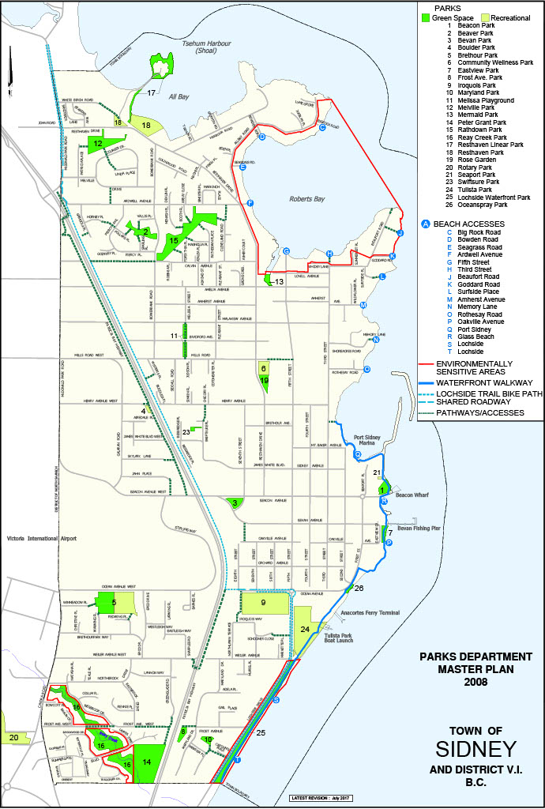
Note: Sidney, 2017
The Town of Sidney is home to the 28 parks and beaches, which are collectively governed by Bylaw No. 1688, “A Bylaw to Establish Rules and Regulations Governing the Use of Public Parks, Including Boulevards and Beaches,” (Sidney, 2001). Falling under the heading “Overnight Accommodation and Erecting Temporary Shelters,” the bylaw lays out a series of location and time-based restrictions that reflect the bylaws previously examined in the districts above. The bylaw begins:
A Homeless Person may take up overnight accommodation and erect or occupy a temporary shelter in a Park between the hours of 7:00 p.m. on one day and 9:00 a.m. the following day (Sidney, 2001).
The framing of this bylaw is notable because Sidney does not introduce any qualifications that must be met before an individual may shelter in a park. Although various location-based restrictions are listed under section 12.1, Sidney’s bylaws differ notably from Central Saanich, Colwood, North Saanich and Saanich.
Section 21.1 the proceeds with eight subsections outlining the regulations for temporary overnight shelters. Subsection a) to d) provide a list of location-based restrictions, ensuring the park’s amenities, such as trails and picnic shelters, remain accessible to the public. Subsection e) declares that any damage to town property, including plants, trees, and infrastructure, is prohibited, while subsection f) mandates that no garbage is left once the unhoused vacate the park. The last two subsections declare that shelters cannot interfere with city employees “in the performance of his duty,” and they must not be erected on roads. These regulations provide clear guidelines for the use of a temporary overnight shelter in Saanich.

Roadways
The town of Sidney has no bylaws forbidding an individual from sheltering within a vehicle in a city park. Although Sidney has few parks compared to many other districts with the CRD, the ability to shelter on park roadways provides more options for those with vehicles.

Sidney’s traffic bylaw prohibits any individual from using a “vehicle or trailer parked on a street for the purpose of lodging, sleeping accommodation or a residence” (Sidney, 2001). This bylaw effectively limits vehicular sheltering on most roadways within Sidney, forcing individuals to seek accommodation elsewhere or risk legal repercussions.

Victoria
The City of Victoria has ten homeless shelters and holds most of the resources for the unhoused within the downtown core. As the Capital of the Province, approximately 94,000 people call Victoria home. However, with the concentration of resource centers for the unhoused centred in and around the Victoria downtown core, homelessness is more visible in Victoria than in many of the other districts in the CRD.
Victoria is home to 105 parks, British Columbia’s Parliament Buildings, and the largest downtown core in the CRD. Stretching across the southern tip of Vancouver Island, the city occupies the homelands of the Songhees and Xwespsum Nations (Victoria, 2025).

Parks
Figure 9
City of Victoria Parks Map

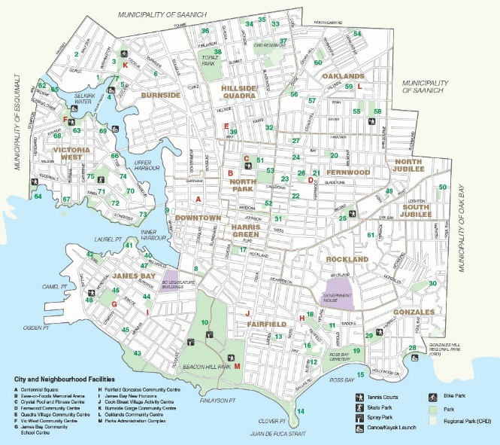
Note: North Jubilee Neighbourhood Association, date unknown

In the City of Victoria, the debate surrounding sheltering in parks has played out extensively in both public discourse and the courts, shaping the city's approach to managing its green spaces. In 2008, the BC Supreme Court ruled that the city was violating the unhoused right “to life, liberty and the security of the person” (Victoria (City) v. Adams, 2008) under section 7 of the Charter. Following this ruling, the city adopted a new set of bylaws aligned with the Supreme Court’s decision.

The Paks Regulation Bylaw, adopted by the City in 2007, begins the discussion of temporary overnight shelters under the heading “Construction.” Point 16 (1) states that an individual:

A person may erect or construct, or cause to be erected or constructed, a tent, building or structure, including a temporary structure such as a tent, in a park only as permitted under this Bylaw, or with the express prior permission of the Council, (Victoria, 2007)

Unlike the other districts examined, the City of Victoria explicitly grants anyone compliant with the bylaw the right to shelter within a park. Although all the other districts' bylaws effectively achieve the same ends, the positive language (“may erect or construct” as opposed to prohibitive language) suggests that this bylaw was directly impacted by the Supreme Court’s ruling.

Under the heading “Overnight Shelter,” the Parks Regulation Bylaw lists a series of regulations for temporary overnight shelters, primarily focused on time and location. The unhoused are only permitted to shelter between 8:00 p.m. and 7:00 a.m. when daylight savings is in effect and only 7:00 p.m. and 7:00 a.m. when it is not.

Like many other districts discussed, the City of Victoria prohibits temporary shelters from occupying space in a playground, sports field, road, or an environmentally or culturally sensitive area. Subsection (3) additionally includes restrictions on the proximity to playgrounds, schools, and other shelters, while additionally limiting the size of the shelter to 9 square metres (Victoria, 2007). These restrictions balance the needs of the unhoused with the public's best interest. However, there are several parks across the City of Victoria where temporary overnight shelters are not allowed (see the entirety of the bylaw in Appendix B). This distinction is important information for the unhoused to ensure their shelter meets the legal requirements outlined in this bylaw.

The final sub-sections under “Overnight Shelter” concern the use of barbeques, stoves, heaters, and flammable liquids in city parks. This section concerns a matter of public safety. The use of heating appliances or open flames in or around a temporary overnight shelter threatens the well-being of the unhoused and the park. However, this regulation poses a significant challenge to the comfort of the unhoused, particularly during extreme cold weather events.

City officials have been criticized for what Martin Girard, a legal advocate at the Victoria Liberation Front, describes as “forced displacement,” or as Victoria News described it, “street sweeps or encampment cleanups” (Laurin, 2024). Furthermore, the harsh actions of bylaw officers have also caught the attention of local graffiti artists. "Bloomsanshit," a Victoria-based graffiti archivist, documented two instances of a "Stop the Sweeps" tag on March 20, 2024 (see Figure 10 and Figure 11), highlighting growing resistance to these enforcement practices. These public displays of opposition, much like past protests, reflect the increasing frustration among community members toward the city's restrictive policies on public space and the treatment of the unhoused. These “sweeps” often lead to dispossession of the unhoused private property when shelters remain past the allotted hours. When these belongings are classified as “refuse” or garbage, the unhoused lose hope of reclamation. This practise encourages the unhoused to find shelter in more precarious or vulnerable locations.

Figure 10
“Stop the Sweeps” Tag – Close Up
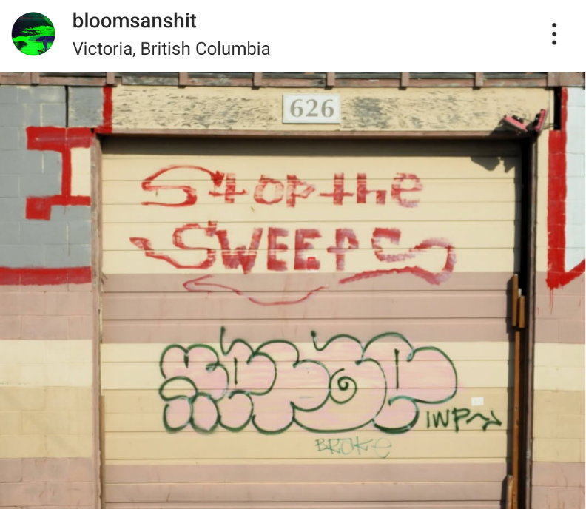
Note: Instagram user “bloomsanshit”, posted March 16, 2025
Figure 11
“Stop the Sweeps” Tag - Distance
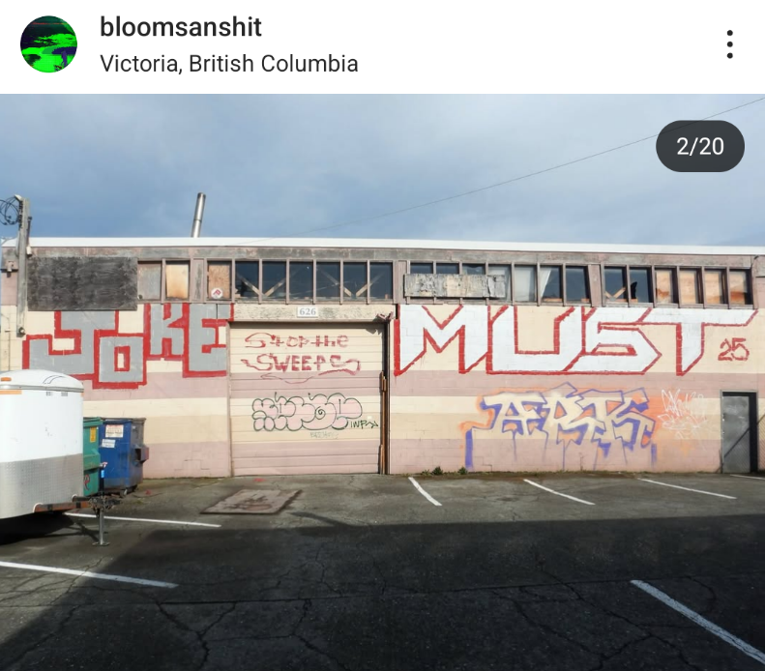
Note: Instagram user “bloomsanshit”, posted March 16, 2025

Roadways

Within the Parks of Victoria, subsection 12 (1) (k) and (l) of the Parks Management Bylaw declare that an individual may sleep inside their car “only if” they have received “prior express permissions” from the Director. While these subsections do not shut down the possibility of sheltering in a vehicle within a city park, they add a barrier that the unhoused must surpass to establish their legal right to shelter (City of Victoria, 2007).

Beyond the parks of Victoria, the city restricts individuals from sleeping in a vehicle parked on a roadway within the city (Victoria, 2009).

Official Community Plans and Homelessness
The City of Victoria adopted a comprehensive Official Community Plan in the summer of 2012, which includes a prolonged discussion of homelessness and affordable housing. The 2012 OCP will serve as the primary source for this section. However, in 2024, the City announced that it would update its OCP to meet the needs of a “growing population and address the housing and climate crises” (Victoria, 2025). While this report will focus on the policies outlined in the 2012-2024 OCP, it is important to note that these policies are currently under review, and they will change with the new OCP.
The City of Victoria directly centers homelessness in the housing discussion by titling Chapter 13, “Housing and Homelessness” (Victoria, 2012). This section begins with a general overview of housing across Victoria, framing the limited housing supply, rising rental costs, low rental vacancy rates, and a growing city population as some of the district's challenges in the coming decade. The discussion then turns to homelessness and how the rising cost of living has resulted in an increase in those at risk of or experiencing homelessness. This analysis is proceeded by a substantial list of policy objectives subdivided into individual sections.
Many of the policies listed discuss the need to expand housing diversity across the city, increasing the number of affordable housing units available for rent/purchase. Increasing the number of affordable housing units can help those at risk of homelessness and improve access to stable housing for lower-income individuals. Additionally, this chapter includes a subsection dedicated to “Transitional, supported and non-market rental housing,” and one entitled “Addressing Homelessness” (Victoria, 2012). The policy objectives listed within these subsections are multifaceted and frequently emphasize the importance of collaboration between the City, non-profit organizations, the private sector, and all levels of government when tackling homelessness.

Municipalities That Do Not Permit Sheltering
Six municipalities across the CRD do not allow temporary overnight shelters in parks: Esquimalt, Highlands, Metchosin, Oak Bay, Sooke, and View Royal. While the bylaws in these municipalities differ in wording, they share the same fundamental outcome: a prohibition on sheltering in parks.

The enforceability of these bylaws remains an open question. In Victoria (City) v. Adams, the BC Supreme Court determined that preventing unhoused individuals from sheltering in public parks, mainly when there is no space available in alternative emergency shelters, is a direct violation of the Charter rights of the unhoused. This ruling established an important precedent, and while municipal bylaws vary, those that impose a complete ban on temporary shelters would likely not be legally sustained if challenged.

The impact of these bylaws restricts the unhoused from legally sheltering within these parks without exception. While their legal viability is questionable at best until challenged or amended, these bylaws severely restrict the sheltering options available to the unhoused. Given their uniform nature, this section of the report will not analyze these bylaws extensively, if at all. Instead, this section will focus on the bylaws governing sheltering on this district's roadways. For a complete listing of the bylaws restricting temporary overnight shelters, see Schedule “B.”

Esquimalt
The township of Esquimalt is located on the traditional territory of Kosapsum (Esquimalt) and Songhees First Nations. Home to approximately 17,655 residents and over 30 parks, Esquimalt is one of the smallest (by square footage) in the CRD (Esquimalt, 2025).

Parks
Figure 12
Esquimalt Parks Map

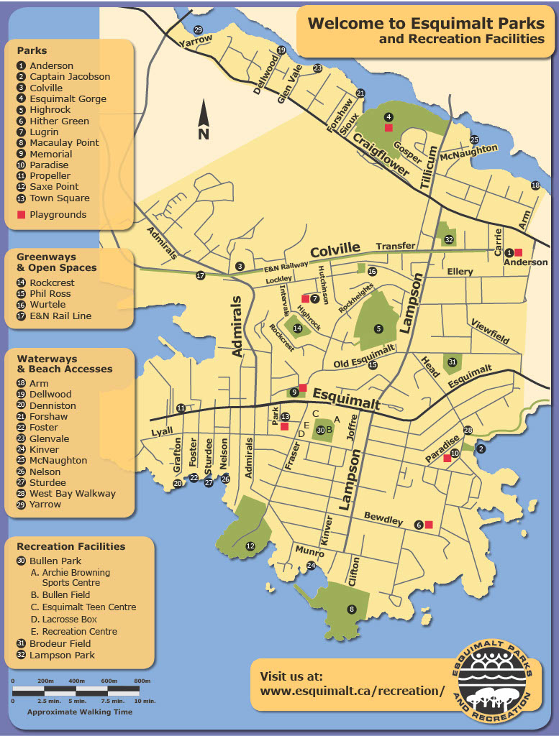
Note: Esquimalt, 2025

Roadways
The township of Esquimalt has two separate bylaws that discuss seeking shelter on roadways. The first, adopted within the Parks and Recreation Regulations bylaw, prohibits allowing a vehicle “to remain in any park or public place between dusk to dawn.” Although this bylaw does not mention sleeping explicitly, the extent of this regulation effectively prohibits individuals from sheltering on park roadways or parking lots.
Located within Part V of the Streets and Traffic Regulation Bylaw, Esquimalt additionally prohibits individuals from sleeping overnight “in any vehicle parked on the street,” (Esquimalt, 2017). Forbidden from seeking shelter on public roadways, parks, or public places within Esquimalt, the unhoused have few options. Private property or parking lots provide the only legal possibility of shelter in the district, and they both come with a list of their barriers to entry.
These bylaws effectively create a comprehensive ban on sleeping in vehicles within Esquimalt's public spaces. It leaves individuals experiencing homelessness or housing insecurity with few options for safe overnight shelter. Without accessible alternatives or designated safe parking areas, those forced to shelter in their vehicles face constant risk of fines, displacement, and further marginalization.

Highlands
The district of the Highlands extends along the Saanich Inlet, the traditional territory of the Ləkʷəŋən, SENĆOŦEN and Hul’q’umi’num speaking First Nations. Primarily a rural and residential district, the Highlands has an extensive collection of provincial, regional, and municipal parks. This wide array of jurisdiction over the green space within this district results in a wide variety of regulations governing the parks within the Highlands (Highlands, 2022.)

Parks
The regulations governing the wide array of parks and natural reserves within the Highlands are diverse, resulting in varying restrictions depending on which park someone may be located in. However, the bylaws governing the use of Eagles Lake Park, a municipal park within the district, expressly prohibit individuals from sleeping overnight within the park (Highlands, 2012).
The bylaw governing the “Management, Control and Use of Eagles Lake Park” prohibits individuals from sleeping “overnight in the park with or without shelter of any kind.” Shelter, by the standards established in this bylaw, includes “a vehicle, recreational vehicle, tent, lean-to, or other natural shelter.” Defining a vehicle as a shelter in this manner effectively expands the scope of the prohibition to encompass a wide range of potential overnight accommodations.
Figure 13
Highlands Parks Map
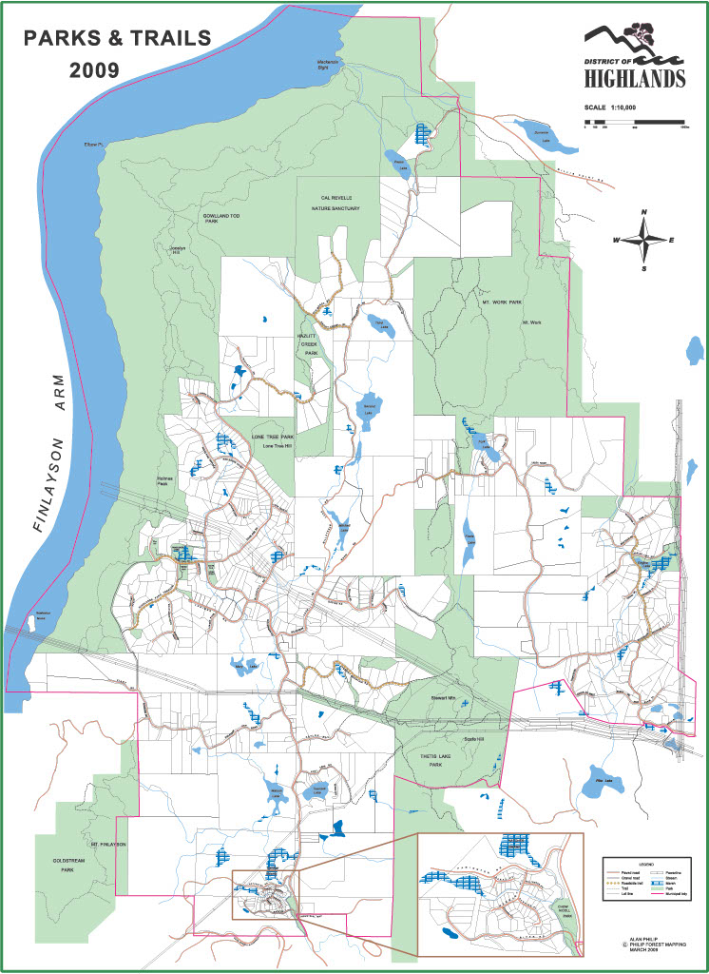
Note: Highlands, 2009

Roadways
The bylaws governing the use of roadways within the Highlands prohibit using a vehicle as a shelter within the district. Falling under the heading “No Lodging,” the regulation states that “[n]o person shall use any vehicle, trailer or camper parker or a road right-of-way for the purpose of lodging, sleeping accommodation or a residence” (Highlands, 2008). This regulation may result in individuals seeking shelter in parking lots or on private property. Without seeking express permission from the individual owning the land, the unhoused risk a confrontation with the property owner or police officers, and parking lots often have their own set of economic or time-based barriers to occupation. The constant threat of displacement can lead people into dangerous locations that may pose a threat to their well-being and safety.

Metchosin
Encompassing the southernmost tip of the CRD, Metchosin is located on the traditional territory of the Scia’new and T’Sou-ke First Nations (Metchosin, 2025). Although a largely rural district, Metchosin is home to only five municipal parks, although several regional parks also fall within the municipal boundaries.

Parks
The Parks Regulation Bylaw, adopted by the district of Metchosin in 2006, restricts individuals from sleeping “in a park with or without a shelter of any kind, including, but not restricted to, a vehicle, a recreational vehicle, tent, lean to, or other natural shelter” (Metchosin, 2006). The language of this regulation echoes that of the Highlands and covers an extensive range of temporary overnight shelters within a single regulation. The language of this regulation leaves little ambiguity and effectively prohibits the use of Metchosin’s parks as a place to shelter. However, various parks governed by the CRD within Metchosin that fall under separate jurisdiction (see Regional Legislation).
Figure 14
Metchosin Parks Map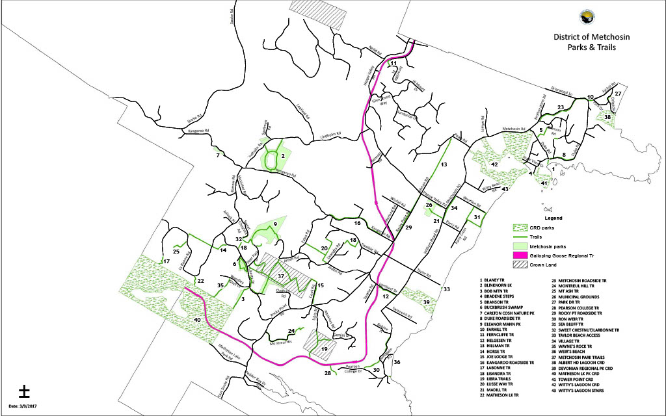
Note: Metchosin, 2017

Roadways
Expanding beyond the Parks Regulation bylaw, Metchosin’s Traffic and Highway Regulations additionally impose strict regulations on using vehicles as a shelter within the district. The bylaw declares that no person may park “upon any portion of a highway for the purpose of taking up overnight abode,” (Metchosin, 1987). The wording suggests that the unhoused may seek shelter within a parking lot. However, the definition provided for “highway” includes “every place or passage way owned or operated by the District of Metchosin for the purpose of providing off-street parking,” effectively taking parking lots out of consideration.

Official Community Plans and Homelessness
The district of Metchosin’s OCP primarily addresses housing through the lens of affordability, focusing on policies that permit secondary and detached suits to mitigate the rising cost of living. Consequently, the OCP does not dedicate significant attention to the discussion of homelessness. However, it acknowledges the issue through a commitment to conducting housing needs assessments and the desire to involve the broader community in developing strategies to address these challenges.

Oak Bay
The district of Oak Bay is located on the traditional territory of the Coast and Straits Salish Peoples, specifically the lək ̓ʷəŋən peoples, today represented by the Songhees and Esquimalt Nations (Oak Bay, 2025).

Parks
The bylaw governing Oak Bay’s Parks and Beaches establishes a set time wherein an individual may park their vehicle within a city park. Under the heading “Traffic/Parking,” section 4. (2) expressly states: “no person shall park any motor vehicle or trailer in any park during the hours between 11:00 p.m. and 6:00 a.m. (Oak Bay, 2017).
Figure 15
Oak Bay Park Map
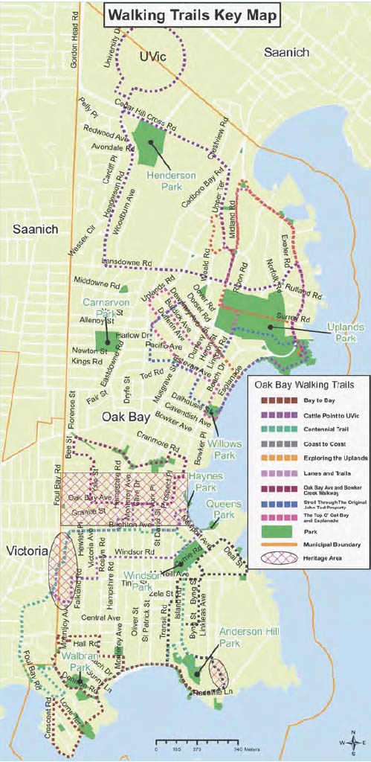
Note: Oak Bay, date unknown

Roadways
Within traffic and street use regulations, the district of Oak Bay has no bylaw that explicitly forbids an individual from sleeping in a parked car. Instead, the bylaw restricts individuals from parking their vehicle in a “municipal parking lot,” between midnight and 6 a.m. The bylaw fails to define “municipal parking lot,” and the land restrictions listed alongside this bylaw provide no further clarification (Oak Bay, 2000). This legislation creates a degree of uncertainty concerning where an individual may or may not seek shelter on roadways within the District.

Official Community Plans and Homelessness
Falling under the heading “Improve Housing Affordability,” Oak Bay’s OCP lists several goals to improve access to affordable housing within the district. These goals include initiatives to develop the district's non-market and affordable housing units. These strategies are important and meaningful when tackling the housing crisis. This OCP acknowledges that more affordable housing will reduce “the number of people in core housing need and those who are homeless” (Oak Bay, 2014). Oak Bay recognizes the role that affordable housing plays in reducing homelessness, and they are making significant strides toward expanding housing options within the district.

Sooke
Home to over 80 parks covering over 285 acres of land, the district of Sooke has several regional and municipal parks within its borders. Located on the “unceded traditional territories of the T’Sou-ke and Scia’new Nations” (Sooke, 2025), Sooke is a small but growing community.

Parks
Figure 16
Sooke Parks Map “A”
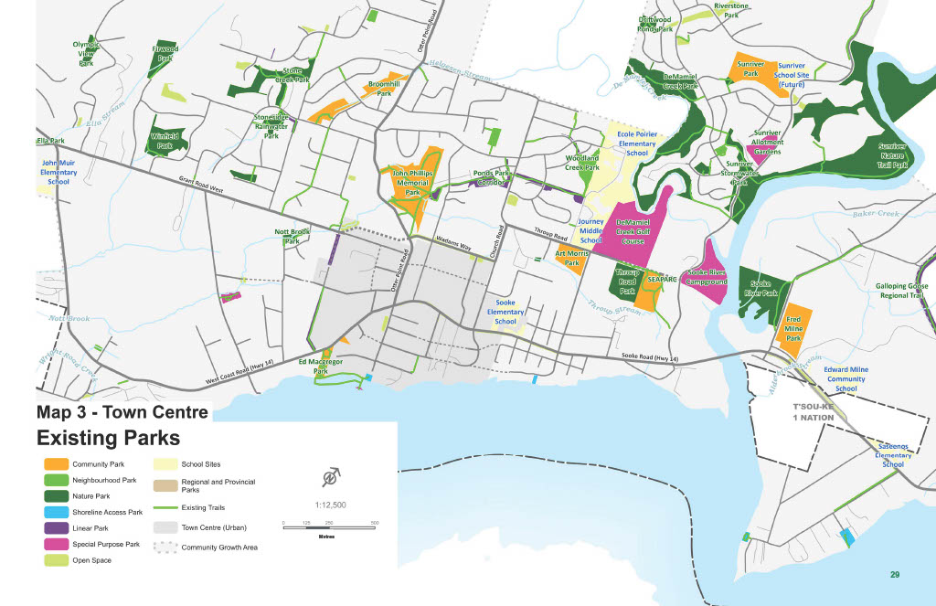
Note: Sooke, 2020
Figure 17
Sooke Park Map “B”
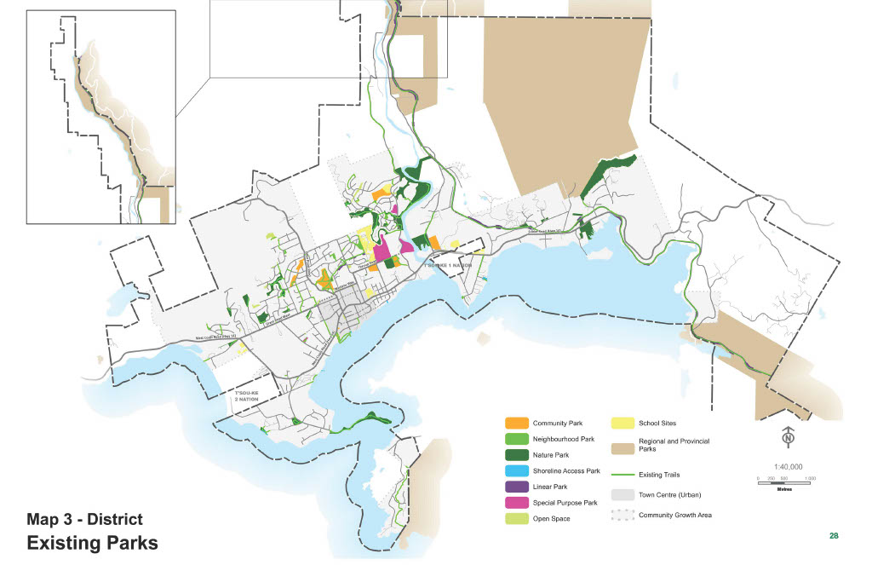
Note: Sooke, 2020

Roadways
Sooke’s Community Parks Regulation Bylaw, adopted by the district in 2002, addresses sheltering in parks and sheltering on park roadways with a single provision:
No person shall camp or sleep overnight in a park with or without a shelter of any kind, including, but not restricted to, a vehicle, recreational vehicle, tent, lean to, or other natural shelter, (Sooke, 2002).
The language of this bylaw echoes similar legislation that we have previously discussed, including the Highlands, Metchosin and Oak Bay.
The same degree of prohibitive legislation can also be found in Sooke’s Traffic and Highways Regulation Bylaw. Under the heading Parking Regulations, the districts mandates that no person shall park “upon any portion of a highway for the purpose of taking up overnight abode,” (Sooke, 2002). Although this bylaw does not appear extensively restrictive, the definition of “highway,” as provided by the bylaw, includes:
(b) every road, highway, lane or right-or-way designed or intended for or used by the general public for the passage of vehicles,
(c) and every place or passage way to which the public, for the purpose of the parking or servicing of vehicles, has access or is invited;
The explicit inclusion of sub-section (c) within this bylaw prohibits individuals from legally sleeping within their vehicles in any public parking spot within the district. Although the definition of “highway” is included in this bylaw, the uncommon definition used to define this term could lead an individual to believe that they are allowed to shelter in their vehicle if they are not on a traditional highway.

Official Community Plans and Homelessness
The district of Sooke discusses homelessness and affordable housing in a section entitled “Housing.” This section identifies that Sooke’s housing mix has not kept pace with the community’s evolving needs. Consequently, Sooke’s OCP focuses a significant portion of the discussion on developing diverse and affordable housing choices for “seniors, young singles, families, and those that are most vulnerable within the community” (Sooke, 2022). Following this overview, the OCP breaks down the housing discussion into individual objectives, policies, and actions to address the objective.
The first objective of “Housing” specifically addresses non-market housing needs, pointing to the broader discussion of affordable housing and homelessness within the district. The OCP encourages the development of “supportive housing” throughout the district, which would integrate social services alongside affordable housing
for those who face complex challenges, including individuals and families who are confronted with homelessness, poverty, and persistent issues such as mental or physical health challenges, disabilities, and substance abuse disorders (Sooke, 2022).
The OCP then proposes three actions to help Sooke achieve its directive: increase non-market housing options, enhance the supportive services for the unhoused community, and leverage capital funds for affordable housing projects. Sooke’s OCP develops a considerable list of policies and actions intent on enhancing the rental supply and lowering the cost of living within the district. Furthermore, the multifaceted lens applied to the discussion of homelessness suggests that the district of Sooke recognizes the complexity of homelessness and the need for targeted support. While the OCP primarily approaches the issue through the lens of housing affordability, its inclusion of supportive housing and social services highlights a commitment to addressing some of the broader challenges unhoused individuals face.

View Royal
The Town of View Royal occupies the unceded traditional territory of the lək ̓ʷəŋən peoples, today represented by the Songhees and Esquimalt Nations. The town intersects with a significant portion of Thetis Lake Regional Park, Esquimalt Harbour and Portage Inlet, providing this municipal district with a wide array of green spaces. Home to approximately 11,600 residents, View Royal is a gateway between Victoria’s downtown core and the western municipalities of the CRD (View Royal, 2025).

Parks
View Royal has not adopted bylaws that explicitly forbid individuals from erecting a temporary overnight shelter within park limits. However, the Parks and Public Places Bylaw does impose a curfew on park use. Listed under the heading "Park Hours,” the bylaw states that “Unless otherwise specified by the Director, Park Areas shall be closed to the public between the hours of 11:00 p.m. and 5:00 a.m. on all days,” (View Royal, 2018). No exceptions are provided alongside this bylaw, suggesting an individual may not seek shelter overnight within this district.
In 2022, Victoria News reported that View Royal was amending its parks bylaw to restrict overnight camping within the district. Although the article suggests that this bylaw has already been adopted, the official bylaws available for the district do not include any such amendment (Samanski-Langille, 2022).
Figure 18
View Royal Parks Map
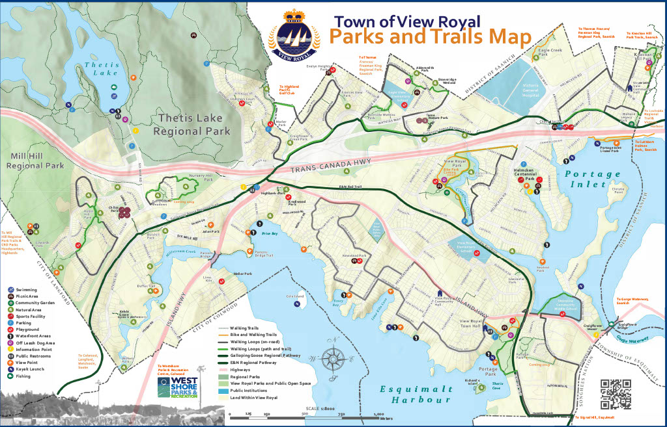
Note: View Royal, 2019

Roadways
The bylaws that govern the parks of View Royal include a specific provision restricting individuals from leaving “a motor vehicle in a parking lot overnight” (View Royal, 2018). Although this section does not explicitly address seeking shelter in a vehicle, the bylaw prevents vehicles from remaining in a municipal park overnight, eliminating the possibility of sheltering on park roadways.
The Streets Bylaw, however, is less restrictive. Under Section 12: Miscellaneous Regulations, the bylaw restricts an individual from sleeping “overnight on any street, including in a vehicle parked on a street,” (View Royal, 2019). Unlike many other districts discussed, “street,” as defined by the district, does not include parking spaces. Although somewhat more open to sheltering on roadways, this bylaw forces the unhoused to seek private property or parking lots without restrictions before they might rest for the night.

REGIONAL LEGISLATION
The CRD, as the regional governing body, unites the 13 municipalities and 3 electoral districts of Vancouver Island. It provides a framework for collaboration amongst the municipalities and coordinates regional services such as water, waste management, and regional parks. For Salt Spring Island, the Southern Gulf Islands, and Juan de Fuca, the CRD additionally functions as the local government, providing legislation and funding for these districts (Capital Regional District, 2025).

Parks
The CRD is responsible for over 13,300 hectares of trails and parks across Southern Vancouver Island (Capital Regional District, 2025). This wide array of stunning green spaces includes some of the most iconic parks across Southern Vancouver Island, including Thetis Lake, East Sooke Park, and Witty’s Lagoon. Collectively, these parks are governed by the Parks Regulation Bylaw (Bylaw No. 4225), adopted by the CRD in March 2019.
The Parks Regulation Bylaw does not contain any specific sections that address temporary overnight shelters within CRD parks. However, there are a series of regulations that specifically apply to camping, outlined in section 6. However, these campsites often come with their own terms and conditions, including registration fees, that make camping untenable for the unhoused. In addition to financial costs, campsites often have regulations regarding registration, check-in procedures, and occupancy limits, further complicating their accessibility for those in crisis. The practical barriers to legal camping, such as these, can leave the unhoused feeling frustrated and helpless, with few lawful alternatives.
Outside of the regulations provided in section 6, the remainder of the parks in the CRD are subject to a curfew between sunset and sunrise (Capital Regional District. 2018). This regulation effectively prohibits the unhoused from seeking shelter in any park overnight. The only exceptions listed within this provision apply to regional trails: “Lochside Regional Trail, the E&N Rail Trail – Humpback Connector, and the Galloping Goose Regional Trail” (Capital Regional District. 2018).
The imposition of a curfew effectively prohibits the unhoused from seeking shelter within a regional park. However, that is not the only limitation imposed upon the unhoused within this bylaw. Falling under the heading “Preservation of Natural Features, Wildlife and Park Features,” the Regional Park Bylaw forbids an individual from erecting a temporary structure or facility with a regional park. When considered alongside the curfew, this bylaw restricts the unhoused from seeking shelter within the CRD’s parks. The CRD’s approach underscores a broader pattern across numerous districts: sheltering in public parks is broadly restricted, even when emergency shelter space is lacking. This broader pattern of park restrictions underscores the urgency of the issue and the need for change.

Roadways
The CRD currently lacks Bylaws that directly govern the roadways between municipalities. Consequently, this section will examine the regulations governing the use of vehicles within the context of regional parks, highlighting the urgency of the need for clear guidelines.
Section 10 of the Parks Regulation Bylaw contains all the bylaws concerning motor vehicles within regional parks. Many of the regulations address the locations where vehicles are permitted and the places where they are not. The bylaw restricts cars from off-roading and prohibits individuals from parking in “No Parking” areas. However, no bylaws expressly forbid an individual from sleeping in their vehicle while parked in a regional park. Instead, point (4) declares that any motor vehicle “left unattended after the closing hours of the regional park” may be towed away at the owner’s expense (Capital Regional District. 2018).
The term 'unattended' is open to interpretation, and it is unlikely that falling asleep in a car should be considered as such. However, as the bylaw stands, an individual who chooses to sleep within their car could be deemed to be in violation of the curfew established by the Parks Regulation Bylaw, potentially leading to unjust consequences.
Ultimately, the CRD’s approach to vehicle dwelling mirrors broader trends in its regulations: while there is no outright ban, restrictions on overnight presence and lack of legal clarity effectively limit the ability of the unhoused to seek shelter in regional parks. These restrictions reinforce a pattern of displacement that, whether intentional or not, make it increasingly difficult for individuals experiencing homelessness to find safe, legal places to rest.

PROVINSIONAL LEGISLATION
The Provincial Government has a comprehensive set of laws governing the parks and roadways throughout the province. While the Motor Vehicle Act (MVA) grants significant legislative authority to each municipality, the province's regulations serve as the default laws for the roads in British Columbia (Motor Vehicle Act, 1996). Furthermore, the 13 municipal districts intersect with five different Provincial Parks: Sooke Potholes Park, Sooke Mountain Park, Goldstream Park, Gowlland Tod Park, and Ƚáuˌwelṉew̱/John Dean Park. Among the electoral districts of Juan de Fuca, Salt Spring, and the Southern Gulf Islands are 13 provincial parks and six ecological reserves – including Satellite Channel Ecological Reserve, just off the southern coast of Salt Spring Island.
Collectively, these parks and ecological reserves are governed by the BC Park Act. Adopted by the province in 1990, the Park Act aims to protect and maintain the province’s wild spaces while establishing strict guidelines for recreational use and enjoyment. These regulations, often designed to protect and preserve natural space, have a direct impact on the unhoused. While the Park Act does not explicitly address the issue of temporary overnight shelters within parks, it does include several provisions that may prove prohibitive to those experiencing homelessness.
These reserves and parks are generally far from major urban centers. While unhoused individuals may access these spaces, and the rules governing them remain relevant, the reality is that most unhoused populations tend to concentrate in areas with higher population density, where they are closer to essential services such as shelters, food resources, and healthcare. As a result, while park regulations play a role in broader discussions about homelessness, the primary concerns and impacts are most pronounced in urban areas rather than remote parklands.

Parks
The Park Act and the Forest and Range Practices Act (FRPA) contains several regulations that could impede the unhoused from legally seeking safe shelter within a provincial park. Section 15 of the FRR explicitly outlines that an individual
may not erect a structure…on a recreation trail, in a trail-based recreation area or on an interpretive forest site unless authorized by a recreation officer (Forest and Range Practices Act, 2004).
“Structure,” as defined by the act includes any “long-term or permanent” “improvements,” including campsites and temporary overnight shelters. Section three of the Park Act begins by stating that “every person must…remove all personal property and dispose of all structures” within 30 days of receiving a written order from a park officer (Park Act, 1996). The window provided by this section is considerable, especially when compared to the time constraints view within the municipalities of the CRD. However, once the 30 days have passed, the Park Act provides park rangers the right to remove personal property and dispose of the structure in question. Any expense incurred by the Province through the forced removal of property and/or rehabilitation of the area falls upon the offending individual as a debt owed.
The limited regulations adopted by the provincial government suggest that temporary overnight shelters have not become a significant issue for park rangers, not to say that the unhoused do not visit or camp in provincial parks. However, their distance from urban centers and resources for the unhoused make provincial parks an unlikely location for the unhoused to seek shelter.
While the Park Act's limitations on structures are relatively moderate, there are several regulations that concern camping within provincial parks. Under Division Seven – “Camping and Picnicking,” the provincial law states that no one is allowed to camp in “frontcountry” or “backcountry less than 2000 hectares in size” unless they are in a campsite or have received authorization from a park officer (Park Act, 1996). This restriction, while aligning with the conservation objectives that guide BC Parks, also highlights the impact of economic privilege on camping. The requirement to pay a fee to access the land legally means that camping becomes a question of economic privilege; only those with enough disposable income are permitted access to the park's campsites. Although these fees are frequently much more affordable than a hotel or rental agreement, they still act as a barrier to entry for those with limited access to a stable income.
Aside from the spatial limitations imposed by the Park Act, section 39 states that an individual “may not camp in a park, conservancy or recreation area for more than 14 days” unless otherwise authorized by a park officer or if they are in a “designated long-stay campsite.” The absence of long-stay campsites on Vancouver Island means that this section effectively regulates the duration of stay for any camper. Juxtaposed against the maximum 14 hours permitted by the districts within city parks, 14 days is a generous length of stay.

Roadways
The Motor Vehicle Act (MVA) is the primary legislation for the use of roadways and cars within the province. Between the MVA and the Park Act, the province has several laws that limit or prohibit individuals from sleeping in their vehicles.
The regulations and laws outlined in the Motor Vehicle Act (MVA) govern traffic conduct on provincial roads. No specific legislation prohibits an individual from sleeping in their car if they park their vehicle legally. The MVA includes various laws that limit where individuals can park; however, these laws are designed to strike a balance between public safety and individual rights, ensuring that they do not place an unreasonable burden on those seeking to park legally. Section 189 of the MVA specifies general restrictions on parking locations, such as prohibiting parking in crosswalks, in front of driveways, or on bridges. Additionally, Section 187 prohibits parking that obstructs traffic flow, and Section 190 requires that vehicles park within 30 cm of the curb (Motor Vehicle Act, 1996). These laws establish a framework for the proper traffic flow but do not specifically target individuals seeking shelter in their cars. Consequently, while the MVA imposes parking restrictions, it does not create significant barriers for those looking to find refuge in their cars.
The Park, Conservancy and Recreation Regulations lists a series of rules that restrict where an individual may park under section 23. These restrictions are highly logical, and prohibit individuals from impeding traffic or damaging vegetation, amongst others. Subsection 23 (2) provides further regulations for the use of a vehicle as a shelter. This regulation limits the use of provincial parks to the hours of “11 p.m. and 7 a.m. the following day,” unless a person is a registered camper or is parked in an “area as permitted by a sign or other device” (Park Act, 1996). These regulations prioritize the use of public parks for those with the means to afford camping materials and fees.

FEDERAL LEGISLATION
While most of the land across the CRD falls under municipal, regional, or provincial control, select regions remain under the federal government's jurisdiction. These lands are primarily associated with military operations, Indigenous territory, or federal government facilities. While members of the community govern Indigenous lands, it's important to note that Indigenous territory is technically considered federal lands. This unique designation means that the laws and regulations imposed regionally and provincially do not apply to the Esquimalt Nation Reserve nor the Tsartlip, Tsawout, Tseycum, and Pauquachin Reserves of the Saanich Peninsula. Given the differential systems of government presiding over the CRD when compared to the First Nations Reserves, this report will not endeavour to examine the regulations on temporary shelters within the Indigenous territory. As a result, this section will focus on the regulations governing the Department of National Defence Lands.

Department of National Defence Lands
The Canadian Department of National Defence (DND) Lands encompasses a distributed property that spans nearly 5,000 hectares over 23 sites across British Columbia’s West Coast (Royal Canadian Navy, 2023). In Constance Cove off Esquimalt Harbour, Canadian Forces Base (CFB) Esquimalt is Canada's second-largest military base (Royal Canadian Navy, 2023). As the primary service provider for ships and personnel that pass through the base, CFB occupies over 10,000 acres of land (Royal Canadian Navy, 2010). While considerable in size, the Canadian government classifies this area as a controlled access zone, severely limiting public access to CFB land.
Surrounded by barbed wire fence and guarded by military officers, anyone who enters the base is subject to the conditions set by the Chief of Defence. Subject to the federal provisions outlined in the Controlled Access Zone Order (Halifax, Esquimalt and Nanoose Harbours), security personnel have broad authority to restrict or prohibit access, conduct searches, and remove any individual who fails to comply with the military’s regulations. The increased surveillance and strict regulations of DND land stand as a significant prohibition to the unhoused occupation of military land. These measures, designed to ensure the safety and security of military operations, create a nearly impenetrable barrier for the unhoused. With limited access and strict enforcement, the possibility of seeking shelter or refuge on military lands like CFB Esquimalt is virtually non-existent.

References

bc211. (2025). Victoria shelter list [PDF]. https://bc.211.ca
bloomsanshit [@bloomsanshit]. (2025, March 16). [Photograph of “Stop the Sweeps” – close up, photo 2 of 20 from Instagram post]. Instagram. https://www.instagram.com/p/DHRuVX1SDsf/?igsh=OTlmNW94c28zOWU1
bloomsanshit [@bloomsanshit]. (2025, March 16). [Photograph of “Stop the Sweeps” – from a distance, photo 3 of 20 from Instagram post]. Instagram. https://www.instagram.com/p/DHRuVX1SDsf/?igsh=OTlmNW94c28zOWU1
British Columbia. (1996). Motor vehicle act, RSBC 1996, c. 318. https://www.bclaws.gov.bc.ca/civix/document/id/complete/statreg/96318_00_multi
British Columbia. (1996). Parks Act, RSBC 1996, c. 344. https://www.bclaws.gov.bc.ca/civix/document/id/complete/statreg/96344_01
British Columbia. (2002). Forest and range practices act, SBC 2002, c. 69. https://www2.gov.bc.ca/gov/content/environment/natural-resource-stewardship/laws-policies-standards-guidance/legislation-regulation/forest-range-practices-act
Capital Regional District. (2018). Capital Regional District Parks Regulation Bylaw No. 1, 2018 (Bylaw No. 4225) [PDF]. https://saltspringfire.com/wp-content/uploads/2019/03/5_PDF-CRD-Bylaw-No.-4225-Capital-Regional-District-Parks-Regulation-Bylaw-No.-1-2018.pdf
Capital Regional District. (2025) Bylaw no. 3795: Community parks regulations (Juan de Fuca and Salt Spring Island electoral areas). [PDF]. https://www.crd.ca/media/file/3795-community-parks-regulations-juan-de-fuca-and-salt-spring-island-electoral-areas
Capital Regional District. (2025). Regional parks & trails. https://www.crd.ca/parks-recreation/regional-parks-trails
Central Saanich. (1985). Bylaw no. 804: Parks, beaches, and other public places bylaw. [PDF]. https://www.centralsaanich.ca/sites/default/files/2023-05/804_con_-_park_bylaw.pdf
Central Saanich. (2019). Bylaw no. 2018: Traffic and highways regulation bylaw. [PDF]. https://www.centralsaanich.ca/sites/default/files/2023-05/2018_traffic_highway_regulation.pdf
Central Saanich. (2025). Our community. https://www.centralsaanich.ca/our-community
Colwood. (2025). Insights & statistics. https://www.colwood.ca/local-government/insights-statistics
Colwood. (2018). Bylaw no. 1700: Official community plan. [PDF]. https://colwood.civicweb.net/Documents/DocumentDisplay.aspx?ID=131567
Colwood. (2019). Bylaw no. 1771: Parks management bylaw. [PDF]. https://colwood.civicweb.net/Documents/DocumentDisplay.aspx?ID=143987
Davis, L., Pauly, B., Gibson, D., & Stancer, D. (2023). 2023 Greater Victoria point-in-time homeless county and housing needs survey. Community Social Panning Council of Greater Victoria for the Capital Regional District Reaching Home Program Community Entity. [PDF]. https://www.crd.ca/docs/default-source/housing-pdf/housing-planning-and-programs/2023-point-in-time-count-report.pdf
Esquimalt. (2007). Bylaw no. 2665: Parks and recreation regulation bylaw. [PDF]. https://www.esquimalt.ca/sites/default/files/docs/municipal-hall/bylaws/2023-07_-_Bylaw_2665_-_Parks_and_Rec_Reg-Consolidated_.pdf
Esquimalt. (2017). Bylaw no. 2898: Streets and traffic regulation bylaw. [PDF]. https://www.esquimalt.ca/media/file/202404-bylaw-2898-streets-and-traffic-regulation-bylawconsolidation1pdf
Esquimalt. (2025). Community profile. https://www.esquimalt.ca/culture-heritage/community-profile
Gaetz, S., Barr, C., Friesen, A., Harr.is, B., Hill, C., Kovacs-Burns, K., Pauly, B., Pearce, B., Turner, A., & Marsolais, A. (2012) Canadian definition of homelessness. Canadian Observatory on Homelessness. www.homelesshub.ca/homelessdefinition
Highlands. (2008). Bylaw no. 300: Roads and traffic bylaw. [PDF]. https://www.highlands.bc.ca/DocumentCenter/View/1222
Highlands. (2012). Bylaw no. 337: District of Highlands Eagles Lake park management, control, and use bylaw. [PDF]. https://www.highlands.bc.ca/DocumentCenter/View/1258
Highlands. (2022). District of Highlands 2022 annual report. [PDF]. https://www.highlands.bc.ca/DocumentCenter/View/8369/2022-Annual-Report_-DRAFT
Langford. (1996). Bylaw no. 177: Municipal parks bylaw. [PDF]. https://langford.ca/wp-content/uploads/2023/04/Bylaw-177-Municipal-Park-Regulation-CONSOLIDATED-to-20231204-1.pdf
Langford. (2008). Bylaw no. 1200: Official community plan. [PDF]. https://langford.ca/wp-content/uploads/2020/10/official-community-plan-1200.pdf
Langford. (2025). Demographics & statistics. https://langford.ca/business/community-profile/lifestyle/?_gl=1*1yacfxy*_gcl_au*MTE1NDAxNjQ5LjE3NDE0MDk0NTc.
Laurin, O. (2024, December 2). ‘People are going to die’: Victoria group protests encampment crackdown — Legal advocate Martin Girard of Victoria Liberation Front considers sheltering a fundamental right. Victoria News. https://www.vicnews.com/news/people-are-going-to-die-victoria-group-protests-encampment-crackdown-7680924
Metchosin. (1987). Bylaw no. 57: Traffic and highways regulation bylaw. https://metchosin.civicweb.net/filepro/documents/?preview=911
Metchosin. (2006). Bylaw no. 532: Parks regulation bylaw. https://metchosin.civicweb.net/filepro/documents/?preview=12
Metchosin. (2025). Community history. https://www.metchosin.ca/community/community-history
National Defence. (2010, January 1). CFB Esquimalt. Royal Canadian Navy. https://web.archive.org/web/20100131211900/http://www.navy.forces.gc.ca/marpac/3/3-w_eng.asp
North Saanich. (2013). Bylaw no. 1261: Streets and traffic bylaw. [PDF]. https://northsaanich.ca/wp-content/uploads/Streets-and-Traffic-Bylaw-1261-Consolidated-Apr2015.pdf
North Saanich. (2018). Bylaw no. 1470: Parks bylaw. [PDF]. https://northsaanich.ca/wp-content/uploads/1470-Parks-Bylaw.pdf
North Saanich. (2025). About North Saanich. https://northsaanich.ca/your-community/about-north-saanich/#:~:text=The%20District%20of%20North%20Saanich,side%20produce%20and%20flower%20stands.
North Saanich. (2025) Employment opportunities. https://northsaanich.ca/local-government/employment/
Oak Bay. (2000). Bylaw no. 4100: Streets and traffic bylaw. [PDF]. https://www.oakbay.ca/wp-content/uploads/2025/02/4100-Streets-Traffic-Bylaw.pdf
Oak Bay. (2014). Bylaw no. 4620: Official community plan. [PDF]. https://www.oakbay.ca/wp-content/uploads/2025/02/4620-Oak-Bay-OCP.pdf
Oak Bay. (2017). Bylaw no. 4672: Parks and beaches bylaw. [PDF]. https://www.oakbay.ca/wp-content/uploads/2025/02/4672-Parks-and-Beaches-Bylaw-2017-consolidated.pdf
Oak Bay. (2025). About Oak Bay. https://www.oakbay.ca/community-culture/about-oak-bay/
Royal Canadian Navy. (2023, August 3). Canadian Forces Base Esquimalt. Maritime Forces Pacific Units. https://www.canada.ca/en/navy/corporate/our-organization/structure/marpac/marpac-units.html
Saanich. (1997). Bylaw no. 7753: Parks management and control bylaw. [PDF]. https://www.saanich.ca/assets/Local~Government/Documents/Bylaws~and~Policies/parks_management_and_control_bylaw_7753.pdf
Saanich. (2002). Bylaw no. 8382: Street and traffic regulations bylaw. [PDF]. https://www.saanich.ca/assets/Local~Government/Documents/Bylaws~and~Policies/streets-and-traffic-regulation-bylaw-2002-no-8382.pdf
Saanich (District) v. Brett, 2018 BCSC 2068. https://www.canlii.org/en/bc/bcsc/doc/2018/2018bcsc2068/2018bcsc2068.html
Saanich. (2024). Bylaw no. 10000: Official community plan. https://www.saanich.ca/assets/Community/Documents/Planning/Strategic~OCP~Update/OCP-adopted-2024%20May-web.pdf
Saanich. (2025). About Saanich. https://www.saanich.ca/EN/main/community/about-saanich.html
Saanich. (2025). Indigenous relations. https://www.saanich.ca/EN/main/community/Indigenous-Relations.html
Samanski-Langille, J. (2022, July 29). View Royal amending its parks bylaw to restrict overnight camping: Restricted camping to be allowed in View Royal and Portage Inlet Linear parks. Victoria News. https://www.vicnews.com/news/view-royal-amending-its-parks-bylaw-to-restrict-overnight-camping-103340
Sidney. (2001). Bylaw no. 1688: Parks bylaw. [PDF]. https://www.sidney.ca/wp-content/uploads/1688-Parks-CON.pdf
Sidney. (2010). Bylaw no. 1966: Streets & traffic bylaw. [PDF]. https://www.sidney.ca/wp-content/uploads/2023/08/1966-Streets-Traffic.pdf
Sideny. (n.d.). Culture & heritage. https://www.sidney.ca/discover-sidney/culture-and-heritage/
Sidney. (n.d.). Discover Sidney. https://www.sidney.ca/discover-sidney/
Sooke. (2002). Bylaw no. 101: Community parks regulation. [PDF]. https://sooke.civicweb.net/filepro/documents/?preview=4002
Sooke. (2002) Bylaw no. 67: Traffic and highways regulations. [PDF]. https://sooke.civicweb.net/filepro/documents/?preview=3999
Sooke. (2022). Bylaw no. 400: Official community plan. [PDF]. https://sooke.civicweb.net/filepro/documents/?preview=4044
Sooke. (2025). First nations & indigenous relationships. https://sooke.ca/our-community/first-nations-indigenous-relationships/
Victoria. (2007). Bylaw no. 07-059: Parks regulation bylaw. [PDF]. https://www.victoria.ca/media/file/parks-regulation-bylaw-consolidated-07-059
Victoria (City) v. Adams, 2008 BCSC 1363. https://www.canlii.org/en/bc/bcsc/doc/2008/2008bcsc1363/2008bcsc1363.html
Victoria (City) v. Adams, 2009 BCCA 563. https://www.canlii.org/en/bc/bcca/doc/2009/2009bcca563/2009bcca563.html
Victoria. (2009). Bylaw no. 09-079: Streets and traffic bylaw. [PDF]. https://www.victoria.ca/media/file/streets-and-traffic-bylaw-consolidated-09-079
Victoria. (2010). Bylaw no. 10-046: Ross Bay Cemetery bylaw. [PDF]. https://www.victoria.ca/media/file/ross-bay-cemetery-bylaw-10-046
Victoria. (2012). Bylaw no. 12-013: Official community plan. [PDF]. https://www.victoria.ca/media/file/ocp-whole-book
Victoria. (2025). Official community plan. https://www.victoria.ca/community-culture/official-community-plan
Victoria. (2025). Reconciliation. https://www.victoria.ca/city-government/reconciliation
Victoria. (2025). Why Victoria. https://www.victoria.ca/building-business/economic-development/why-victoria
View Royal. (2018). Bylaw no. 986: Parks and public places bylaw. [PDF]. https://www.viewroyal.ca/assets/Town~Hall/Bylaws/986%20-%20Parks%20and%20Public%20Places.pdf
View Royal. (2019). Bylaw no. 980: Streets bylaw. [PDF]. https://www.viewroyal.ca/assets/Town~Hall/Bylaws/980%20-%20Streets%20Bylaw.pdf
View Royal. (2025). About View Royal. https://www.viewroyal.ca/EN/main/discover/about-view-royal.html

Appendix A: Glossary

The glossary provides a general definition of terms pulled from the terms defined in the Bylaws referenced in this report.
“Affordable Housing”
“At Large”
“Authorized Personnel”
“Beach/Public Beach”
“Boulevard”
“Campsite”
“Cause an Obstruction”
“Chattel”
“Culturally Sensitive Area”
“Curfew Hours”
“Environmentally Sensitive Area”
“Foreshore”
"Frontcountry" means an area in a park, conservancy or recreation area within one kilometre of either side of the centreline of a park road or a highway;
“Highway/Dedicated Highway”
“Homeless Person”
“Lane”
“Linear Park”
“Motor Vehicle/Vehicle”
“Motorcycle”
“Natural Park Feature”
“Nuisance”
“Open Space”
“Park”
“Playground”
“Private Lane”
“Qualifying Occupant” *Sidney Bylaw specific
“Recreation Facility” *Esquimalt specific
“Roadway”
“Solicit”
“Special Event”
“Street”
“Sunrise”
“Sunset”
“Temporary Accommodation/Temporary Overnight Shelter/Temporary Shelter”
“Traffic Control Device”
“Trail”
“Vehicle”

Appendix B: CRD Bylaw for Parks and Roads
Table B, below, presents a comprehensive list of all bylaws that relate to sheltering in parks or roadways active in the CRD as of February 2025. Each bylaw can be accessed through the references listed at the end of this report. Please note, when it was not necessary to provide “Restrictions” to the bylaw under discussion, the collum was merged to conserve space.
Table B
District | Bylaw Number | Key Provisions | Restrictions
CRD | Bylaw No. 3795 | 6. Camping  (2) Subsection (1) does not apply to a homeless person, where the person erects a temporary shelter in the community park only between the hours of 11:00 p.m. and 7:00 a.m. and removes the temporary shelter from the park between 7:00 a.m. and 11:00 p.m. | (3) Despite subsection (2), a homeless person must not erect a temporary shelter in a playground, sports field, foot path, a road within a park, environmentally sensitive area, or any area within a park that has been designated for an event or activity under a valid and subsisting permit issued under the authority of this Bylaw.
Central Saanich | Bylaw No. 804 | 13. (a) Despite Section 13(1) of this bylaw, where there is no accessible shelter accommodation available in the District, a Homeless Person may erect, occupy, and use a Temporary Overnight Shelter:  (i) on Public Lands that is not a Prohibited Area or  (ii) in any area within a park that has not been designated for an event or activity under a valid and subsisting permit issued under the authority of this bylaw, provided that the Homeless Person complies with all other provisions of this bylaw.  (b) Temporary Overnight Shelters shall only be erected, occupied or used each evening between the hours of 7:00 p.m. on one day and 9:00 a.m. of the following day, provided that the Homeless Person:  (i) not erect the Temporary Overnight Shelter until after 7:00 p.m. on one day;  (ii) take down and remove the Temporary Shelter prior to 9:00 a.m. of the following. | 13. (c) Each Temporary Overnight Shelter referred to in Section 13A(b) above may only cover an area of less than 10 m² and may not adjoin, abut, or be connected to any other Temporary Overnight Shelter.  (d) A Temporary Overnight Shelter shall not be erected, occupied, or used in, on, within, or attached to any Prohibited Area.  (f) Any Temporary Overnight Shelter on Public Lands that is found:  i) in, on, within, or attached to any Prohibited Area; or  ii) during times not authorized by this Bylaw, shall be unlawful and subject to enforcement and removal, including the removal of any possessions, waste, and other incidental materials in, at, or near the erection, occupancy, or use of the Temporary Overnight Shelter.  (g) All Persons using Temporary Overnight Shelter on Public Lands shall be required to comply with all other provisions of this Bylaw and any other applicable District Bylaw, and Provincial or Federal Act or Regulation.  (h) Without limiting any other authority granted under this Bylaw, a Bylaw Enforcement Officer may remove or cause to be removed from Public Lands any Temporary Overnight Shelter that is not in compliance with this Bylaw, including any camping equipment, or possessions in, at, or near the Temporary Overnight Shelter.
Colwood | Bylaw No. 1771 | 5. Temporary Overnight Shelters  (1) Except as provided in subsection (2) no person shall:  (a) camp overnight in or on any portion of any park or beach;  (b) constructor place in or on any portion of any park or beach a tent or temporary building or structure without first obtaining a special events permit;  (2) Where there is no accessible overnight shelter accommodation available within the City of Colwood or the vicinity thereof, a person who has neither a fixed address nor a predictable safe resident to return to on a daily basis may, subject to the restrictions set out in subsection (3), erect and occupy a temporary overnight shelter in a park. | (3) A temporary overnight shelter permitted under subsection (2) must not be erected before 7:00 pm on any one day and must be taken down and removed before 8:30 am on the next day.  (4) A temporary overnight shelter permitted under subsection (2) must not be erected or occupied at any time upon or within;  (a) 40 meters of any:  i) playground, spray park or pools;  ii) horticultural display areas or gardens;  iii) skateboard bowls, tennis courts, or other sport courts;  iv) sport fields, stadiums or dugouts;  v) stages or bleachers;  vi) recreation facilities  vii) beaches  ix) cemeteries;  x) golf courses;  xi)pathways, bridges, boardwalks, docks or wharves,  xii) any land designated in the Land Use Bylaw as P5 Zone Natural Parks; or  xiv) area of a park that has been designated for an event or activity under a valid and subsisting permit issued by the City.  (b) 10 meters of an established trail, sidewalk or private property; or  (c) an environmentally sensitive area  (5) In addition to abiding by the regulations in section 4(1) and 4(2) of this Bylaw, a person who has erected a temporary overnight shelter permitted under subsection (2) must not:  (a) obstruct a highway or interfere with the lawful use of a person or vehicle using a highway;  (b) obstruct a City employee in the performance of their duties
Highlands | Bylaw No. 377 | CURFEW  13. No person shall enter upon or otherwise remain within the park for any purpose whatsoever between 10:00 p.m. and 7:00 a.m.  CAMPING  26. No person shall camp or sleep overnight in the park with or without shelter of any kind, including but not restricted to, a vehicle, recreational vehicle, tent, lean-to, or other natural shelter.
Highlands | Bylaw No. 300 | No Lodging  5.16 No Person shall use any vehicle, trailer or camper parked on a road right-of-way for the purpose of lodging, sleeping accommodation or a residence.
Juan de Fuca and Salt Spring Island Electoral Area | Bylaw No. 3795 | 6. Camping  (2) Subsection (1) does not apply to a homeless person, where the person erects a temporary shelter in the community park only between the hours of 11:00 p.m. and 7:00 a.m. and removes the temporary shelter from the park between 7:00 a.m. and 11:00 p.m. | (3) Despite subsection (2), a homeless person must not erect a temporary shelter in a playground, sports field, foot path, a road within a park, environmentally sensitive area, or any area within a park that has been designated for an event or activity under a valid and subsisting permit issued under the authority of this Bylaw.  (4) Nothing in this section will permit any person to violate any other section of this Bylaw at any time.
Langford | Bylaw No. 177 | 4.13. Despite subsection 4.10, subsection 4.11 and subsection 4.12 of this Bylaw, where there is no accessible overnight shelter accommodation available within  the City or the vicinity thereof, a homeless person may erect and occupy a temporary overnight shelter in a park subject to the restrictions set out in subsection | 4.14. 4.14. A temporary overnight shelter permitted under subsection 4.13:  (a) must not be erected before 7:00 p.m. on any one day and must be taken down and removed before 7:00 a.m. on the next day following when Daylight Saving Time is not in effect;  (b) must not be erected before 8:00 p.m. on any one day and must be taken down and removed before 7:00 a.m. on the next day following when Daylight Saving Time is in effect;  (c) must not be erected or occupied at any time in, upon or within 10 meters of any of the following:  (i) washroom facilities;  (ii) a road, driveway or parking facilities;  (iii) a pathway, trail, bridge, boardwalk, dock or wharf;  (iv) a beach;  (v) land designated on the City’s official community plan as development permit areas for the purpose of protecting the natural environment; and  (d) must not be erected or occupied at any time in, upon or within 100 metres of any of the following:  (i) a playground, spray park or pool;  (ii) a horticultural display area or garden;  (iii) a tennis court or other sport court;  (iv) a sport field, stadium or dugout;  (v) a stage or bleachers;  (vi) a picnic shelter or gazebo;  (vii) recreation facilities;  (viii) a cenotaph; and  (e) must not occupy more than 9 square meters in area, including all associated objects and possessions.
Metchosin | Bylaw No. 57 | 3.1 Parking Regulations  Except to comply with the directions of a peace officer, or traffic control device or traffic patrol or an emergency vehicle which is in actual use for official duties, no person shall park:  (...)  (29) upon any portion of a highway for the purpose of taking up overnight abode;
Metchosin | Bylaw No. 532 | Fires and Camping  6. No person shall light or keep lit any fire in a park.  7. No person shall camp or sleep overnight in a park with or without a shelter of any kind, including, but not restricted to, a vehicle, a recreational vehicle, tent, lean to, or other natural shelter.
North Saanich | Bylaw No. 1470 | Temporary Overnight Shelter  22. Where there is no overnight shelter accommodation available within the District or the vicinity thereof, a homeless person may erect and occupy a temporary overnight shelter in a park subject to the following restrictions:  (a) temporary overnight shelter must not be erected before 7:00 p.m. in any one day and must be taken down and removed before 9:00 a.m. on the following day; | (b) temporary overnight shelter must not be erected at any time within or upon any of the following:  (i) playgrounds;  (ii) horticultural display areas or gardens;  (iii) tennis courts, pickleball courts or other sport courts or fields;  (iv) washroom facilities, picnic shelters or gazebos;  (v) recreation facilities;  (vi) beaches;  (vii) trails, bridges, boardwalks, docks or wharves; or  (viii) roadways.  23. Temporary overnight shelter must not be erected on a dedicated highway
Oak Bay | Bylaw No. 4672 | Traffic/Parking  4. (1) No person shall park any motor vehicle or trailer or allow it to remain in any park except in a portion of a park designated for parking.  (2) With the exception of a person using a boat-ramp for launching purposes while his boat is in use in the sea, no person shall park any motor vehicle or trailer in any park during the hours between 11:00 p.m. and 6:00 a.m.
Oak Bay | Bylaw No. 4672 | Miscellaneous  23. (1) No person, without first obtaining the written permission of the Director, shall erect a tent, building, structure or shelter in or on any park.  (2) No person shall camp, or take up temporary or permanent abode in or on any park.
Saanich | Bylaw No. 7753 | Regulations  14.1. a) Despite section 14 of this Bylaw, where there is no accessible overnight shelter accommodation available within the District of Saanich or the vicinity thereof, a homeless person may erect and occupy a temporary overnight shelter in a park subject to the restrictions set out in Schedule “C” (See Appendix B) attached hereto. | See Appendix C
Saanich | Bylaw No. 7753 | Regulations  14.1. a) Despite section 14 of this Bylaw, where there is no accessible overnight shelter accommodation available within the District of Saanich or the vicinity thereof, a homeless person may erect and occupy a temporary overnight shelter in a park subject to the restrictions set out in Schedule “C” (See Appendix C) attached hereto.  (b) Any temporary overnight shelter erected or occupied in a park contrary to the restrictions set out in Schedule “C” (See Appendix C) attached hereto constitutes a chattel unlawfully deposited in a park which may be removed, seized, impounded and sold in accordance with the provisions of section 29
Sooke | Bylaw No. 101 | Camping  32. No person shall camp or sleep overnight in a park with or without a shelter of any kind, including, but not restricted to, a vehicle, recreational vehicle, tent, lean to, or other natural shelter.
Sooke | Bylaw No. 101 | Vehicles and Parking  48. No person shall park any vehicle in a park, except in a parking lot while that person is lawfully using the park.
Sydney | Bylaw No. 1688 | Overnight Accommodation and Erecting Temporary Shelter  12.1 A Homeless Person may take up overnight accommodation and erect or occupy a Temporary Shelter in a Park, between the hours of 7:00 pm on one day and 9:00 am the following day, provided the Homeless Person:  (see “Restrictions” in the adjacent collum) | 12.1 A Homeless Person may take up overnight accommodation and erect or occupy a Temporary Shelter in a Park, between the hours of 7:00 pm on one day and 9:00 am the following day, provided the Homeless Person:  a) does not erect the Temporary Shelter, or occupy, or take up overnight accommodation, within 100 meters of any playground, community garden, sports field, tennis court, picnic shelter, gazebo, stage, water park, skate park, parking lot public washroom, ornamental garden, or horticultural display;  b) does not erect the Temporary Shelter, or occupy, or take up overnight accommodation, on or within 50 metres of an established trail or sidewalk;  c) does not erect the Temporary Shelter, or occupy, or take up overnight accommodation, within 100 metres of private property;  d) does not erect the Temporary Shelter, occupy, or take up overnight accommodation within 200 metres or any area of a park that has been designated for an event or activity under a valid and subsisting permit issued by the Town; e) does not damage or alter Town property, including fencing, trees, shrubs, plantings, benches, or other equipment or infrastructure;  f) removes the Temporary Shelter by 9:00 am each morning and does not leave possessions, debris, litter or any other article behind, and does not return before 7:00 pm the same day;  g) does not obstruct a highway or interfere with the lawful use of a person or vehicle using a highway; h) or does not obstruct a Town employee in the performance of his duty.  12.2 Notwithstanding section 12.1, no person may enter, occupy, or remain within a public facility, picnic shelter, gazebo, stage or other permanent structure or facility between the hours of 11pm and 7am.
Esquimalt | Bylaw No. 2665 | 3. Park Regulations  3.1 Prohibited Acts  3.1.5 No person may enter, occupy or remain in a park:  a) between dusk and dawn except as permitted pursuant to Schedule "A"; (See Appendix D)  b) for the purpose of taking up overnight abode; or  c) by crossing any area where signs have been erected pursuant to this Bylaw forbidding such crossing.  3.1.10 Erect, construct or build or cause to be erected, constructed or built in or on any park, public place or boulevard any tent, building, shelter, pavilion or other construction without the prior express permission of the Director.  3.1.11 Live or take up quarters in a park as either a temporary or permanent abode.  3.1.22 Park any vehicle or trailer or allow it to remain in any park or public place except where parking is designated. No person may park any vehicle or trailer or allow it to remain in any park or public place between dusk to dawn.
Victoria | Bylaw No. 10-046 | (Ross Bay Cemetery)  Part 7 – General Regulations  Permission to enter cemetery during prohibited times  42. A person shall not, without the prior written permission of the Director, enter or remain in the cemetery between:  (a) the earlier of 11:00 p.m. or one hour after sunset of a day, and  (b) the later of 6:00 a.m. or one hour before sunrise of the next calendar day.
Victoria | Bylaw No. 07-059 | Closing Hours  9. (1) A person must not cause a vehicle to be in Clover Point Park between 11:00 p.m. of one day and 6:00 a.m. of the next day.  (2) A person must not use the road leading to the lookout in Beacon Hill Park, known as Checkers Pavilion, between one-half hour after sunset of one day and one-half hour before sunrise of the next day.  (3) A person must not enter or remain in any of the following parks between one hour after sunset of one day and one hour before sunrise of the next day:  (a) Moss Rocks Park;  (b) Franklin Green;  (c) Pioneer Square.  (4) A person must not enter or remain in Victoria Youth Park between 10:30 p.m. of one day and 7:00 a.m. of the following day.
Victoria | Bylaw No. 07-059 | Overnight Shelter  (2) A homeless person must not place, secure, erect, use, or maintain in place, in a park, a structure, improvement or overhead shelter, including a tent, lean-to, or other form of overhead shelter constructed from a tarpaulin, plastic, cardboard or other rigid or non-rigid material:  (a) subject to sub-section (b), except between the hours of:  (i) 7:00 o’clock p.m. of one day and 7:00 o’clock a.m. of the next day when Daylight Saving time is not in effect; and  (ii) 8:00 o’clock p.m. of one day and 7:00 o’clock a.m. of the next day when Daylight Saving time is in effect, | (2) A homeless person must not place, secure, erect, use, or maintain in place, in a park, a structure, improvement or overhead shelter, including a tent, lean-to, or other form of overhead shelter constructed from a tarpaulin, plastic, cardboard or other rigid or non-rigid material:  (b) at any time, in  (i) a playground, sports field, footpath or road within a park,  (ii) an environmentally or culturally sensitive area, community garden, or horticultural area,  (iii) any area within a park that has been designated for an event or activity under  (A) a valid and subsisting permit issued under the authority of this Bylaw, or  (B) a lease, licence, or other agreement authorized by Council,  (iv) Arbutus Park,  (v) Bastion Square,  (vi) Beacon Hill Park,  (vii) Cecelia Ravine Park,  (viii) Centennial Square,  (ix) Central Park,  (x) Coffin Island,  (xi) Cridge Park,  (xii) David Spencer Park,  (xiii) Haegert Park,  (xiv) Hollywood Park,  (xv) Irving Park,  (xvi) Kings Park,  (xvii) MacDonald Park,  (xviii) Moss Rocks Park,  (xix) Quadra Park,  (xx) Reeson Park,  (xxi) Regatta Point Park,  (xxii) Robert Porter Park,  (xxiii) South Park,  (xxiv) Stadacona Park,  (xxv) Summit Park,  (xxvi) Topaz Park, or  (xxvii) Vic West Park.  (c) at any time within 4 metres of a private property line,  (d) at any time, in any area identified by the Director as susceptible to flooding, erosion, slope instability, or other environmental hazards, provided that signage has been erected to indicate the area as such.  (3) Notwithstanding subsection (2), person must not place, erect, maintain or use a shelter in a park at any time  (a) within 8 metres of a playground,  (b) 4 metres of any area listed in section 16A(2)(b),  (c) 4 metres of any other shelter that is placed, erected, maintained or used in accordance with section 16A or this section,  (d) within 50 metres of a school as defined in the School Act, or  (e) that, including all associated objects or possessions, occupies more than 9 square meters in size.  (4) A person must not keep, store, or use in a park  (a) a barbeque, stove, heater, or any other open flame appliance,  (b) or a propane tank, gasoline container, or any other flammable gas or liquid.
Vicotria | Bylaw No. 07-059 | Part 3- General Regulations  Traffic and parking  (1) A person may do any of the following activities in a park only if that person has received prior express permission under section 5:  (h) park a vehicle in a park for longer than 3.5 hours between 7:00 a.m. and 6:00 p.m. of any day from Monday to Friday;  (k) park a vehicle in a park for the purpose of sleeping overnight in the vehicle;  (l) sleep overnight in a vehicle in a park;
View Royal | Bylaw No. 986 | 6.0 Damage to Property  6.1. No person shall:  (d) begin or continue the construction, placement or deposit of any structure or matter, or dig in the soil, without prior written authorization of the Director or a Park Permit;  6.2 No person shall build or place any temporary or permanent structure in a Park Area, without prior written authorization of the Director.
View Royal | Bylaw No. 986 | 11.0 Parking Lots  11.2 Without limiting Sections 10.1 and 10.2, no person shall:  (a) leave a Motor Vehicle in a Parking Lot overnight; or  (b) act contrary to any traffic control device in a Parking Lot.
View Royal | Bylaw No. 986 | 17. Park Hours  17.1 Unless otherwise specified by the Director, Park Areas shall be closed to the public between the hours of 11:00 p.m. and 5:00 a.m. on all days.
View Royal | Bylaw No. 980 | Section 12: Miscellaneous Regulations  Sleeping in Vehicles  12.3. A person is not permitted to sleep overnight on any Street, including in a vehicle parked on a Street.

Appendix C: Saannich – Bylaw 7753 - Schedule “C”

Schedule “C”, referenced in Saanich Bylaw no. 7752; “For the Management, Control and Use of Parks, Beaches and Other Public Places within the district of Saanich,” details the restrictions on temporary shelters permitted within the district of Saanich. For further details on other sheltering bylaws within the CRD, please refer to Appendix A.
Restrictions on Temporary Overnight Sheltering
1. A temporary overnight shelter permitted under section 14.1(a) of this Bylaw must not be erected before 7:00 p.m. on any one day, and must be taken down and removed before 7:00 a.m. on the next day following.
2. A temporary overnight shelter permitted under section 14.1(a) of this Bylaw must not be erected or occupied at any time within or upon any of the following:
(i) an environmentally sensitive area;
(ii) a playground, spray park or pool, or any area within 3 metres of a playground, spray park or pool;
(iii) a horticultural display area or garden; (iv) a skateboard bowl, tennis court or other sports court, or any area within 3 metres of a skateboard bowl, tennis court or other sports court;
(v) a sports field, stadium or dugout, or any area within 3 metres of a sports field, stadium or dugout;
(vi) a stage or bleachers, or any area within 3 metres of a stage or bleachers;
(vii) a washroom facility, picnic shelter or gazebo, or any area within 3 metres of a washroom facility, picnic shelter or gazebo;
(viii) a recreation facility, or any area within 3 metres of a recreation facility; (ix) a beach; (x) a cemetery;
(xi) a golf course;
(xii) a pathway, bridge, boardwalk, dock or wharf;
(xiii) a road, driveway or parking facility.
3. A homeless person permitted to erect and occupy a temporary overnight shelter under section 14.1(a) of this Bylaw may do so only in a park listed below and in no other park:
a) Agate Park;
b) Allenby Park;
c) Baxter Park;
d) Beckwith Park;
e) Bernard Park;
f) Blair Park;
g) Braefoot Park;
h) Broadmead Park;
i) Brodick Park;
j) Browning Park;
k) Brydon Park;
l) Cadboro-Gyro Park;
m) Casa Marcia Park;
n) Cecelia Creek Falls Park;
o) Cedar Hill Park;
p) Claremont-Goddard Park;
q) Commonwealth Place Park;
r) Copley East Park;
s) Copley West Park;
t) Cordova Bay Park;
u) Craigflower-Kosapsom Park;
v) Edge Park; w) Emily Carr Park;
x) Estelline Park; y) Fairburn Park;
z) Fowler Park;
aa) Francisco Park;
bb) Glanford Park;
cc) Glencraig Park;
dd) Gore-Peace Memorial Park;
ee) Gorge Park; ff) Gorge Waterway Park;
gg) Goward Park;
hh) Hampton Park;
ii) Harvest Lane Park;
jj) Horner Park;
kk) Houlihan Park;
ll) Hyacinth Park;
mm) Industrial Buffer Park;
nn) Kenmore Park;
oo) King Alfred Park;
pp) Lambrick Park;
qq) Leeds Park;
rr) Lochside Park;
ss) Majestic Park;
tt) Maltwood Park;
uu) Marigold Park;
vv) Maynard Park;
ww) McBriar Park;
xx) McMinn Park;
yy) McMorran Park;
zz) Meadow Park;
aaa) Montague Park;
bbb) Mount View Park;
ccc) Onyx Park;
ddd) Outerbridge Park;
eee) Panama Hill Park;
fff) Parkwood Park;
ggg) Perez Park;
hhh) Playfair Park;
iii) Prospect Lake Park;
jjj) Qu’Appelle Park;
kkk) Rainbow Park;
lll) Regina Park;
mmm) Reynolds Park;
nnn) Rogers Park;
ooo) Rogers Court Park;
ppp) Rosedale Park;
qqq) Rudd Park;
rrr) Rutledge Park;
sss) Sayward Hill Park;
ttt) Sierra Park;
uuu) South Valley Park;
vvv) Springridge Park;
www) Tolmie Park;
xxx) Tyndall Park;
yyy) Unnamed Park at 4394 West Saanich Road;
zzz) Unnamed Park on Walter Ave at Dysart Road;
aaaa) Vantreight Park;
bbbb) Vic Derman Park;
cccc) Whitehead Park.

Appendix D: Esquimalt – Bylaw No. 2664 – Schedule “A”

Schedule “A,” referenced in Esquimalt’s Parks and Recreation Bylaw No. 2665, details the hours of operation for park facilities in Esquimalt.

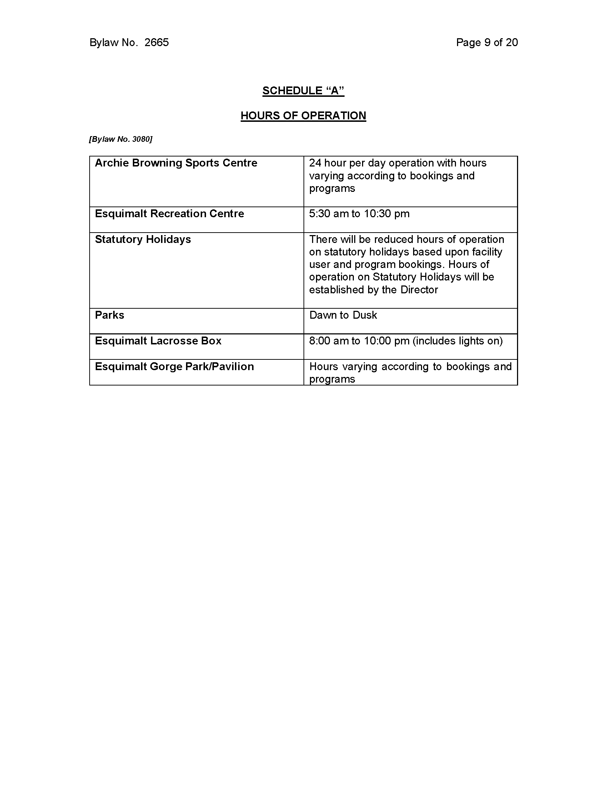

Appendix E: British Columbia – Motor Vehicle Act – Regulations on Parking
The Motor Vehicle Act contains the provincial legislation governing the use of motor vehicles on public roads in British Columbia. The Act is extensive, containing 48 chapters and over 300 pages. The full text of the Motor Vehicle Act, including regulations on driver licensing, vehicle registration, traffic safety, and enforcement, can be accessed through the Government of British Columbia’s official website. The five sections below (187, 189-192) detail the legislative regulation on parking imposed by the province.
Where parking prohibited
187 (1) Subject to subsection (3), if outside of a business or residence district it is practicable to stop, park or leave a vehicle off the roadway, a person must not stop, park or leave the vehicle either unattended or attended on the roadway.
(2) Subject to subsection (3), a person must not park a vehicle so as to obstruct the free passage of traffic on the highway.
(3) Subsections (1) and (2) do not apply when a vehicle is so disabled that it is not practicable to avoid stopping and temporarily leaving it on a highway.
When vehicle stopping prohibited
189 (1) Except when necessary to avoid conflict with traffic or to comply with the law or the directions of a peace officer or traffic control device, a person must not stop, stand or park a vehicle as follows:
(a)on a sidewalk or boulevard;
(b)in front of a public or private driveway;
(c)in an intersection, except as permitted by a sign;
(d)within 5 m of a fire hydrant measured from a point in the curb or edge of the roadway that is closest to the fire hydrant;
(e)on a crosswalk;
(f)within 6 m of the approach side of a crosswalk;
(g)within 6 m on the approach to a flashing beacon, stop sign or traffic control signal located at the side of a roadway;
(h)within 6 m either side of the entrance to or exit from a hotel, theatre, public meeting place, dance hall, fire hall or playground in rural area;
(i)within 15 m of the nearest rail of a railway crossing;
(j)subject to subsection (4), on a highway for the principal purpose of
(i)displaying a vehicle for sale,
(ii)advertising, greasing, painting, wrecking, storing or repairing a vehicle, unless repairs are necessitated by an emergency,
(iii)displaying signs, or
(iv)selling flowers, fruit, vegetables, sea foods or other commodities or articles;
(k)alongside or opposite a street excavation or obstruction when stopping, standing or parking obstructs traffic;
(l)on the roadway side of a vehicle stopped or parked at the edge or curb of a roadway;
(m)on a bridge or other elevated structure on a highway, or in a highway tunnel, except as permitted by a traffic control device;
(n)in a place in contravention of a traffic control device that gives notice that stopping, standing or parking there is prohibited or restricted;
(o)in a manner that obstructs the visibility of a standard traffic sign erected by or with the authority of the minister responsible for the administration of the Transportation Act, a municipality, a treaty first nation, the Nisg̱a'a Nation or a Nisg̱a'a Village.
(2) A person must not move a vehicle that is not lawfully under the person's control into a place mentioned in subsection (1).
(3) Despite subsection (1) (f) and (g), a municipality may provide by bylaw that, if authorized by a sign posted by the municipality, a person may park a cycle or motorcycle within 6 m of the approach side of a crosswalk or within 6 m on the approach to a flashing beacon, stop sign or traffic control signal if the cycle or motorcycle is
(a)of a size that, and
(b)parked so that
the cycle or motorcycle does not obstruct a motorist's view of the crosswalk, flashing beacon, stop sign, traffic control signal or an intersection.
(3.1) If a municipality enacts a bylaw referred to in subsection (3), or a treaty first nation or a Nisg̱a'a Government enacts a law having the same effect, a person may park a cycle or motorcycle in accordance with the bylaw or law.
(4) Subsection (1) (j) does not apply to a person acting under and in accordance with an authorization given under section 62 (2) or (6) of the Transportation Act.
Manner of parking
190 Except when a municipality, a treaty first nation, the Nisg̱a'a Nation, a Nisg̱a'a Village or the minister responsible for the administration of the Transportation Act permits, a driver must not stop, stand or park a vehicle on a roadway other than on the right side of the roadway and with the right hand wheels parallel to that side, and where there is a curb, within 30 cm of the curb.
Leaving parked vehicle
191 (1) A motor vehicle must be equipped with a lock or other device to prevent the unauthorized use of the motor vehicle.
(2) A driver must not permit a motor vehicle to stand unattended or parked unless the driver has
(a)locked it or made it secure in a manner that prevents its unauthorized use, and
(b)if the motor vehicle is standing on a grade, turned the front wheels of the vehicle to the curb or side of the highway.
Parking on private property
192 (1) If a motor vehicle or trailer is left without the occupier's consent on private property in a municipality, treaty lands or Nisg̱a'a Lands or for a period exceeding 72 hours on private property not in a municipality, treaty lands or Nisg̱a'a Lands, the owner of the motor vehicle or trailer is deemed to have authorized and empowered the occupier to be the owner's agent for the purpose of towing it to a place of storage and of storing it.
(2) The agent has a lien against the motor vehicle or trailer for all reasonable advances made or charges incurred in connection with the towing and storing of it in the course of the agency.
(3) The procedure respecting enforcement of the lien must be governed by the Warehouse Lien Act.

